**FINAL PORTFOLIO**

The Misfits

**FOOD GALORE**

**Team Members:**

**Aayush Lal Rajbhandari c7227239**

**Aman kumar Shrestha c7227255**

**Pratiksha Manandhar c7229147**

**Sanjeev Lamsal c7227203**

**Top Bahadur Rana c7227240**

**TABLE OF CONTENT**

1. Project Planning

a. Project Charter V1 pg 5-6 pg 5

b. Project Charter V2 pg 7-8

c. Belbin Analysis

I. Team Belbin Analysis pg 9-15

II. Individual Belbin Analysis pg 15-19

1. M

d.Skills Audit

I. Team Skills Audit pg 20-21

II. Individual Skills Audit pg 22

e. Project Management

I. Gantt Chart pg 23

II. Task Sheet pg24 38

III. Timeline pg 25

IV. Resource Sheet pg 26-27

V. Calendar pg 28

VII. Change in Working Time pg 44

f. Communication and collaboration tools pg 29

g. Team Meetings pg29 30293063

2. Product Designing

a. EERD

I.ERD pg 31

II. EERD pg 32

III. Composite EERD pg 32

IV. Final Composite EERD

V. Logical pg 33

b. Use Case Diagram

I. Overview Use Case Diagram pg 34

II. Customer Use Case Diagram pg 34

III. Admin Use Case Diagram pg 35

IV. Trader Use Case Diagram pg 36

c. Requirement Catalogue

I. Functional Requirements pg 38-43

II. Non_Functional Requirements pg 44

d. Logo Design pg 44

e. Wireframes pg 45-53

3.

Product Development

a. Screenshots pg 54-62

b. Website Homepage

index page pg 54-62

4.

Product Testing

a. Customer Interface Testing pg 62-73

b. Trader Interface Testing (PHP) pg 74-82

c. Trader Interface Testing (APEX) pg 83-88

d. Admin Interface Testing (PHP) pg 89-95

e. . Admin Interface Testing (ORACLE) pg 96-104



5. Frequently Asked Questions pg105

**Initiation Phase**

**1.1 Project Charter V1**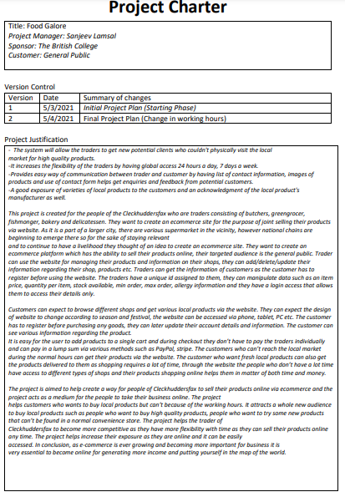

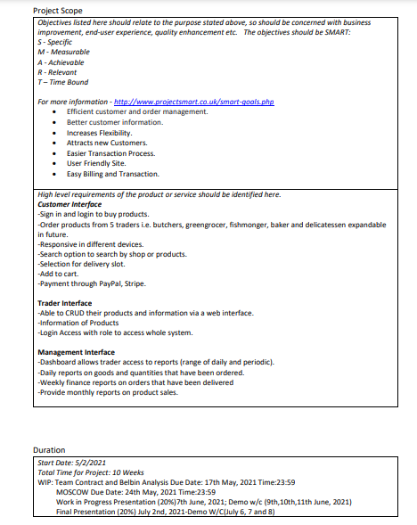

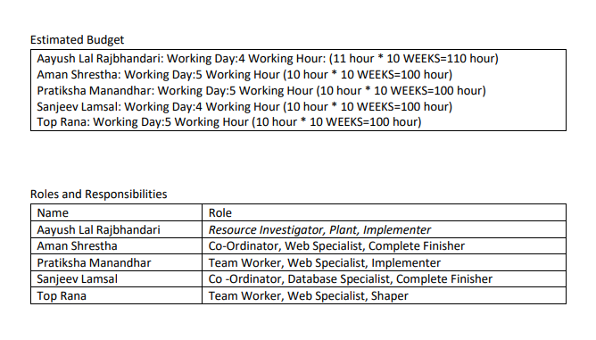

**Project Charter v2**

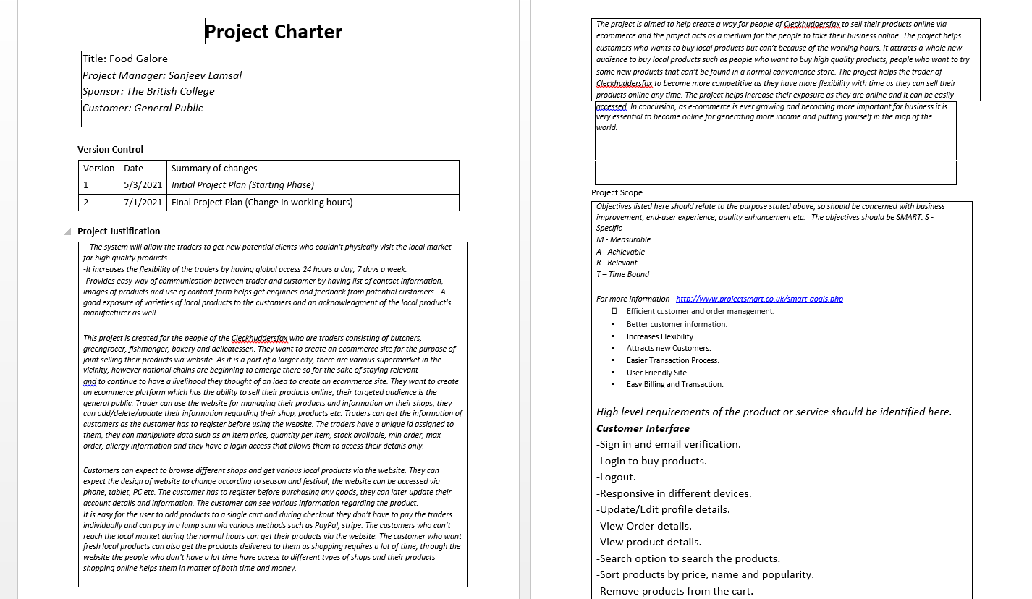

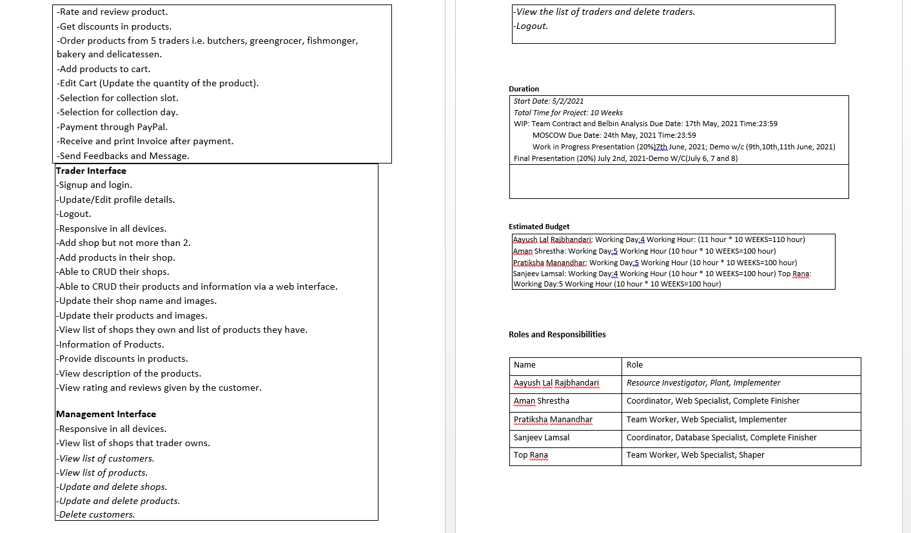

**Belbin Analysis**

**Team Belbin**

|  |  |  |
| --- | --- | --- |
| Version:1.0                     **Belbin’s Analysis** Date reviewed: 7/5/2021 | | |
| Primary role | Aayush  Rajbhandari | Resource Investigator |
| Aman Shrestha | Co-Ordinator |
| Pratiksha Manandhar | Team Worker |
| Top Bahadur Rana | Team Worker |
| Sanjeev Lamsal | Co-Ordinator |
| Secondary role | Aayush  Rajbhandari | Plant |
| Aman Shrestha | Specialist |
| Pratiksha Manandhar | Specialist |
| Top Bahadur Rana | Specialist |
| Sanjeev Lamsal | Specialist |
| Least likely role | Aayush Rajbhandari | Implementer |
| Aman Shrestha | Complete Finisher |
| Pratiksha Manandhar | Implementer |
| Top Bahadur Rana | Shaper |
| Sanjeev Lamsal | Complete Finisher |
| Do you think the descriptions of these roles are an accurate description of your behavior in teams? How do you see yourself differently? | Aayush Rajbhandari | Yes, these roles are a perfect description of my behavior in the team.  I stick to the nature of my roles most of the time but I am very unpredictable, when it comes to ideas. I think of creative and out of the box ideas which might be a bit of a hassle. At first people might find it a bit difficult to understand and not see the vision but when they finally start to understand it they can see the bigger picture as well. |
| Aman Shrestha | Yes, I believe the descriptions of the roles are accurate representations of my behavior in my team. I honestly believe I create a workable plan to keep working on the project and assisting my team with new ways to overcome problems they confront during the project. And I am able to work under pressure and make good decisions. |
| Pratiksha Manandhar | Yes, the role describes my behavior perfectly as I have always been a good listener and I can bring forth ideas and information. And I feel I can do my best on my given tasks. |
| Top Bahadur Rana | Yes, they are indeed accurate descriptions of my behavior. I think I have the ability to identify the work requirements, get the team together to work on it. Similarly, I am a self-starting and dedicated person. I bring depth knowledge on specific topics to the team. I also ensure that our teams keep going on and do not lose focus on hassle. |
| Sanjeev Lamsal | Yes, in the sense that I have been helping the team with Content Writing and Database and No, in the sense that I have been of very little help in Programming. |
| Are there roles identified by Belbin that you might like to develop in yourself more? Which ones and why? | Aayush Rajbhandari | The role that I most want to develop would definitely be implementer.  The role of implementer is to plan a workable strategy and carry it out as efficiently as possible. It would ease the team as the whole team would know what work they have to do and they can bring their A game to the project. |
| Aman Shrestha | I'd like to develop the habit of considering all ideas while working on a project and of being motivated the majority of the time. This might make it easier for me to keep an open mind and work more efficiently. |
| Pratiksha Manandhar | I'd like to enhance the Plant skills since those are qualities I wish to have: creative, innovative, and free-thinking. These abilities, in my opinion, are necessary for personal development. |
| Top Bahadur Rana | Yes, there are roles that I might like to develop. There’s one I want to develop the most is Coordinating. I have always been fascinated by leadership and inspiring other people and that’s the reason why I want to add that skill to my arsenal. |
| Sanjeev Lamsal | The one skill that I would really like to develop more is my coordinating or say, leadership skill as it matches with what I want to be and do in the future. |
| What possible situations in the coming months can you identify where you could work on developing these skills? | Aayush Rajbhandari | In the final month the pressure will be felt by most individuals as a lot of work has to be done and a lot of fixing as well.  My secondary role of a plant will be really helpful for the whole team as I can find a good way of solving any issues and problems which will take pressure off the team. If I can develop my skill of a plant it will not only be helpful for the current project but as well as the future projects that I will be doing. |
| Aman Shrestha | The purpose of our team is to create a well-functioning e-commerce website. As a part of the team, I'd like to contribute new and unique ideas for the website. As a result, I see myself improving these talents in order to provide a high-quality website. |
| Pratiksha Manandhar | Take time to evaluate the situation, consider all possible scenarios, and, if possible, request time to conduct additional research. |
| Top Bahadur Rana | In the coming few months, I would like to develop Plant skills and I am sure I will be able to be better at it due to the countless team meetings and productive and creative works that are to be done in our project. |
| Sanjeev Lamsal | As the assignment is a hefty task, I am sure there will be a lot of scenarios where I may have to motivate my team and motivate myself in order to complete the project on deadline. So I am sure there will be plenty of chances in the coming months. And also to add that, Leadership skill is something that I want to keep developing till the last day of my life, not only for this project. |
| Considering your team working, how do you think you could improve your effectiveness in group work and in contributing to the success of teams that you work in? | Aayush Rajbhandari | My current team is already very efficient as the work that needs to be done is divided among the five members and they complete the tasks in time, they join the meetings in time and tell their individual ideas which makes work really easy.  The only thing that I can do to improve is work and fulfill my responsibilities as I have been doing since the start of the project. |
| Aman Shrestha | When it comes to working in a group, each member's skill and interests should be kept in mind before making a decision.  I'd like to enhance my communication skills with other teammates so that I can urge them to contribute more. |
| Pratiksha Manandhar | Teamwork can be made easier by identifying difficulties, setting reasonable goals in the team, defining team members, encouraging friendships among group members, and cooperating. So, I would like to improve my communication skills with other team members. |
| Top Bahadur Rana | By sticking to our plans, increasing our capability in critical situations, and completing tasks to the best of our abilities. Also by identifying problems, setting smart goals and communicating with team members can make teamwork easier. |
| Sanjeev Lamsal | The one thing which really matters when you get yourself in a long project is keeping yourself motivated and dedicated. That is one of the hardest things to do. So even though I have really high dedicated team members in my team, sharing new ideas and motivating each other might really help in improving effectiveness. |
| Are the results of this inventory consistent with how you worked in the Foundation Project in your small groups for discussions and presentations? | Aayush Rajbhandari | No, as we all know life isn't easy there are always many ups and downs in life.  Similarly, in the project there were many difficulties that we had to face. The result we expected wasn't exactly on par but I have no regrets as we have made it work somehow. |
| Aman Shrestha | Yes, the results of this inventory are consistent during group discussions and presentations since it has helped me recognize my strengths and how to use them to improve my work. |
| Pratiksha Manandhar | Yes, it was consistent, as a team worker I cooperated with my team members on the tasks, uplifting one another's morals while also providing my members with knowledge that I researched. |
| Top Bahadur Rana | Yes, the inventory's results are consistent. If any team member requires assistance or finds the task assigned to them difficult, I am always willing to assist them in finishing the task. |
| Sanjeev Lamsal | Of course, it was not consistent with how we had discussed earlier. We have to keep in mind that none of us have had working experience before so we can’t be good at something in the first try. |
| How well do you want to contribute to group presentations? | Aayush Rajbhandari | I want to give my 100% for the group presentations as giving presentations has been taught to me since childhood. My school put emphasis on teaching students how to give presentations as public speaking is really necessary to express your project. |
| Aman Shrestha | I recognize the value of collaborative work; thus I want to participate fully in group presentations or discussion that needs my participation. |
| Pratiksha Manandhar | I'd like to dedicate all of my efforts and ideas to my group presentations. I am excited to learn, contribute, and research on topics where I am lacking, as well as complete the responsibilities that have been allocated to me. |
| Top Bahadur Rana | In order to participate successfully in the group presentations, I will follow the duties indicated by the Belbin analysis as well as my work. I will also contribute my best efforts to completing the tasks. |
| Sanjeev Lamsal | As a leader of the group, I want to leave no stone unturned when giving our presentation. Especially since every team member's marks depend on each other’s performance. So rather than only focusing on myself, I want to bring our A- game as a team. |

**Individual Belbin**

**Sanjeev Lamsal**

|  |  |  |
| --- | --- | --- |
| Do you think the descriptions of these roles are an accurate description of your behaviour in teams? How do you see yourself differently? |  | Yes, in the sense that I have been helping the team with Content Writing and Database and No, in the sense that I have been of very little help in Programming. |
| Are there roles identified by Belbin that you might like to develop in yourself more? Which ones and why? |  | The one skill that I would really like to develop more is my coordinating or say, leadership skill as it matches with what I want to be and do in the future.The role of implementer is to plan a workable strategy and carry it out as efficiently as possible. It would ease the team as the whole team would know what work they have to do and they can bring their A game to the project. |
| What possible situations in the coming months can you identify where you could work on developing these skills? |  | As the assignment is a hefty task, I am sure there will be a lot of scenarios where I may have to motivate my team and motivate myself in order to complete the project on deadline. So I am sure there will be plenty of chances in the coming months. And also to add that, Leadership skill is something that I want to keep developing till the last day of my life, not only for this project. |
| Considering your team working, how do you think you could improve your effectiveness in group work and in contributing to the success of teams that you work in? |  | The one thing which really matters when you get yourself in a long project is keeping yourself motivated and dedicated. That is one of the hardest things to do. So even though I have really high dedicated team members in my team, sharing new ideas and motivating each other might really help in improving effectiveness. |
| Are the results of this inventory consistent with how you worked in the Foundation Project in your small groups for discussions and presentations? |  | Of course, it was not consistent with how we had discussed earlier. We have to keep in mind that none of us have had working experience before so we can’t be good at something in the first try. |
| How well do you want to contribute to group presentations? |  | As a leader of the group, I want to leave no stone unturned when giving our presentation. Especially since every team member's marks depend on each other’s performance. So rather than only focusing on myself, I want to bring our A- game as a team. |

**1.2 Meetings and Minutes**

|  |  |  |  |  |  |  |
| --- | --- | --- | --- | --- | --- | --- |
| **Week** | **Date** | **Place** | **Meeting Days** | **Meeting time** | **Meeting Agendas** | **Participants** |
| **Week 2** | **03/05/2021** | **Google Meet** | **Monday** | **12:00 to 2:00** | **Project Charter Completion.** | **Aayush Lal Rajbhandari ,Aman Kumar Shrestha ,Pratiksha Manandhar ,Top Bahadur Rana ,Sanjeev Lamsal** |
| **04/05/2021** | **Google Meet** | **Tuesday** | **11:37 to 1:23** | **Discussed Team Contract.** |
| **09/05/2021** | **Google Meet** | **Sunday** | **11:48 to 1:10** | **Discussed Skill Audit.** |
| **11/05/2021** | **Google Meet** | **Tuesday** | **6:33 to 7:34 pm** | **Finalised Skill Audit.** |
| **Week 3** | **19/05/2021** | **Google Meet** | **Sunday** |  | **Discussed ERD, EERD, Composite, Logical Table** | **Aayush Lal Rajbhandari ,Aman Kumar Shrestha ,Pratiksha Manandhar ,Top Bahadur Rana ,Sanjeev Lamsal** |
| **21/05/2021** | **Google Meet** | **Friday** |  | **Finalised ERD, EERD, Composite, Logical Table.** |
| **Week 4** | **24/05/2021** | **Google Meet** | **Monday** | **1:07 to 2:07** | **Discussed Use Case Diagram** | **Aayush Lal Rajbhandari ,Aman Kumar Shrestha ,Pratiksha Manandhar ,Top Bahadur Rana ,Sanjeev Lamsal** |
| **27/05/2021** | **Google Meet** | **Thursday** | **12:30 to 1:57** | **Finalised use case diagram** |
| **26/05/2021** | **Google Meet** | **Wednesday** | **12:30 to 2:23** | **Divided Wireframe between team members.** | **Aayush Lal Rajbhandari ,Aman Kumar Shrestha ,Pratiksha Manandhar ,Top Bahadur Rana ,Sanjeev Lamsal** |
| **27/05/2021** | **Google Meet** | **Thursday** | **12:30 to 2** | **Finalised Logo.** |
| **week 5** | **31/05/2021** | **Google Meet** | **Monday** | **1:03 to 2:30** | **Discussed MOSCOW.** | **Aayush Lal Rajbhandari Aman Kumar Shrestha Pratiksha lal Manandhar Top Bahadur Rana Sanjeev Lamsal** |

**Planning Phase**

**2.1 Belbin’s Analysis (Team)**

|  |  |  |
| --- | --- | --- |
| Version:1.0 Belbin’s Analysis Date reviewed:12/15/2021 | | |
| **Primary role** | Aayush Lal Rajbhandari | Resource Investigator |
| Aman Kumar Shrestha | Coordinator |
| Pratiksha Manandhar | Team Worker |
| Top Bahadur Rana | Team Worker |
| Sanjeev Lamsal | Coordinator |
| **Secondary role** | Aayush Lal Rajbhandari | Plant |
| Aman Kumar Shrestha | Web specialist |
| Pratiksha Manandhar | Web specialist |
| Top Bahadur Rana | Web specialist |
| Sanjeev Lamsal | Database specialist |
| **Least likely role** | Aayush Lal Rajbhandari | Implementer |
| Aman Kumar Shrestha | Complete finisher |
| Pratiksha Manandhar | Implementer |
| Top Bahadur Rana | Shaper |
| Sanjeev Lamsal | Complete Finisher |

**2.2 Skill Audit(Team)**

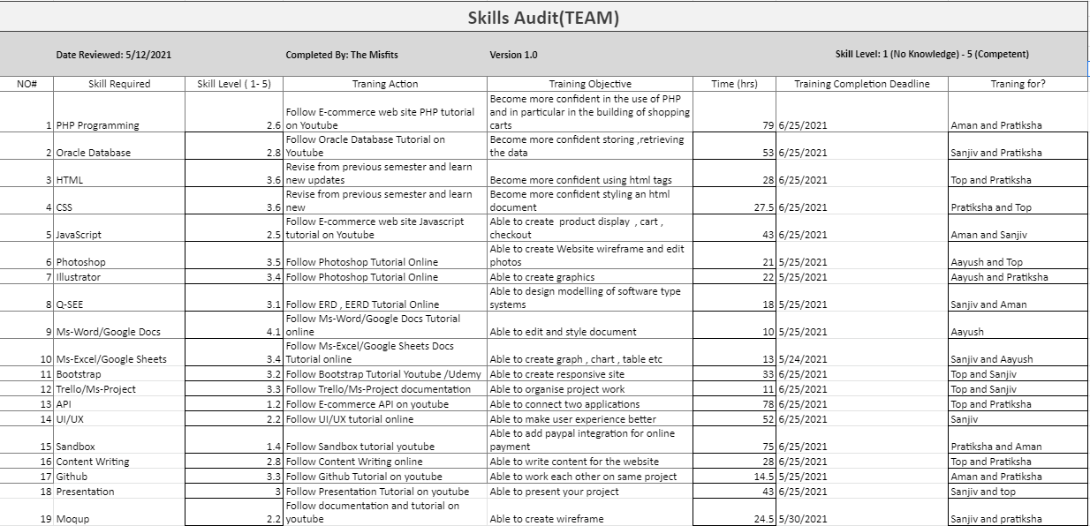

**2.2 Skill Audit (Individual)**

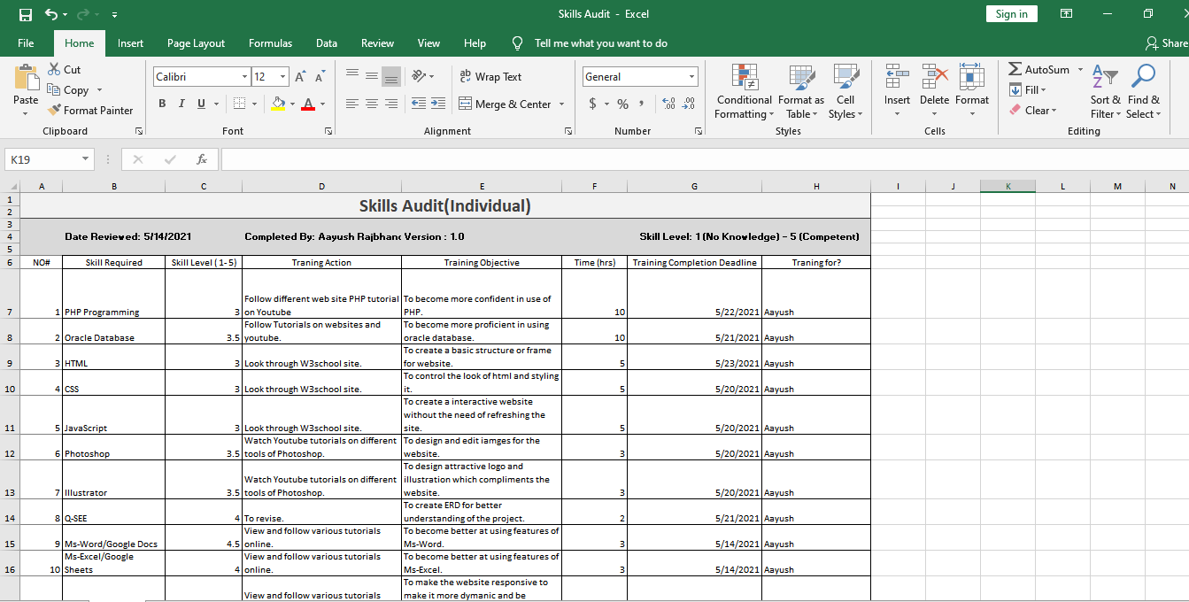

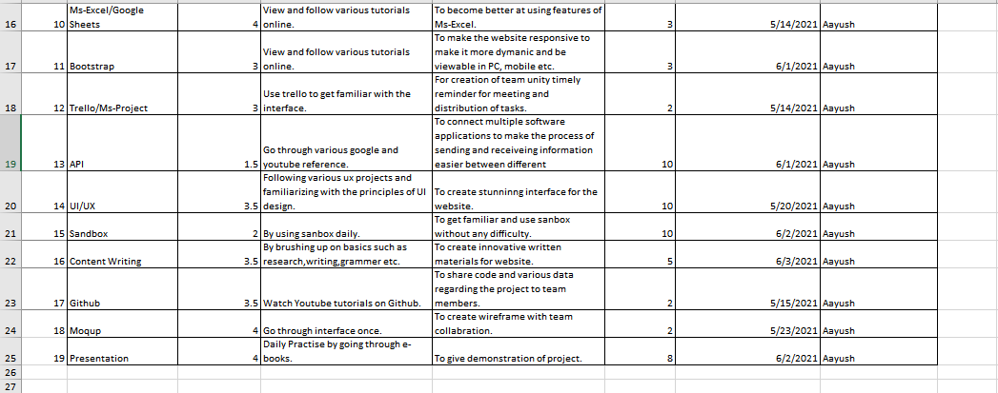

**2.3 MS-PROJECT**

**Gantt Chart:**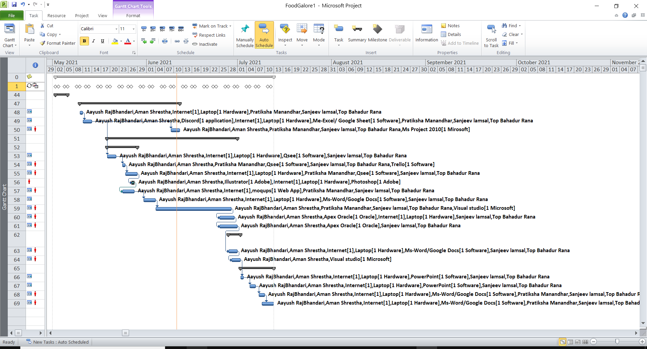

**Timeline**

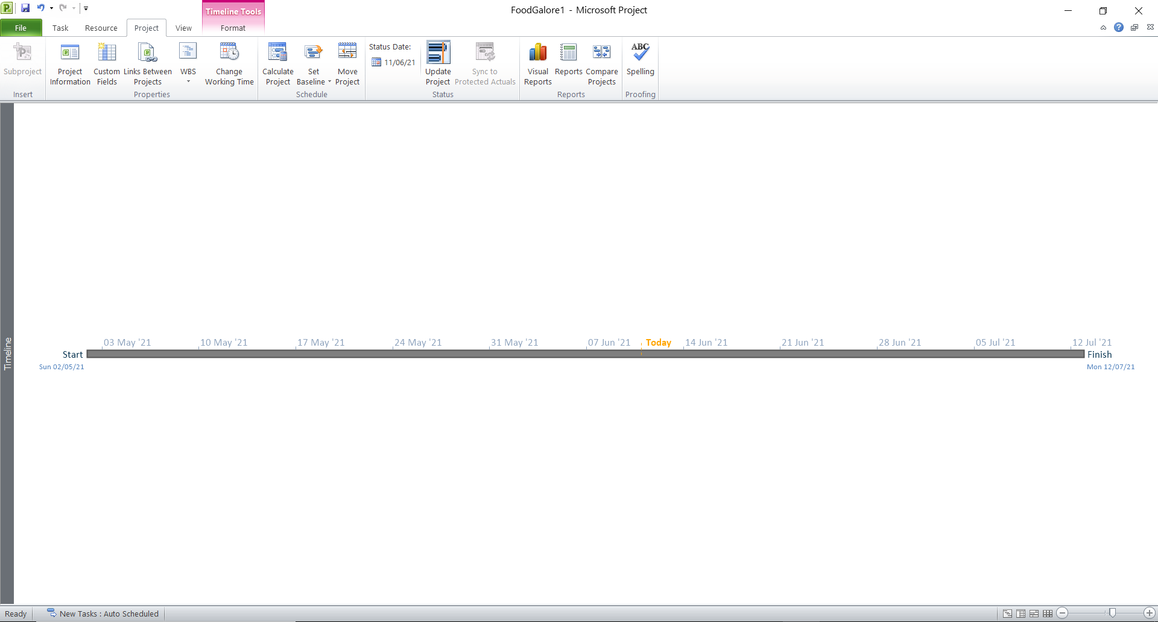

**Network Diagram**

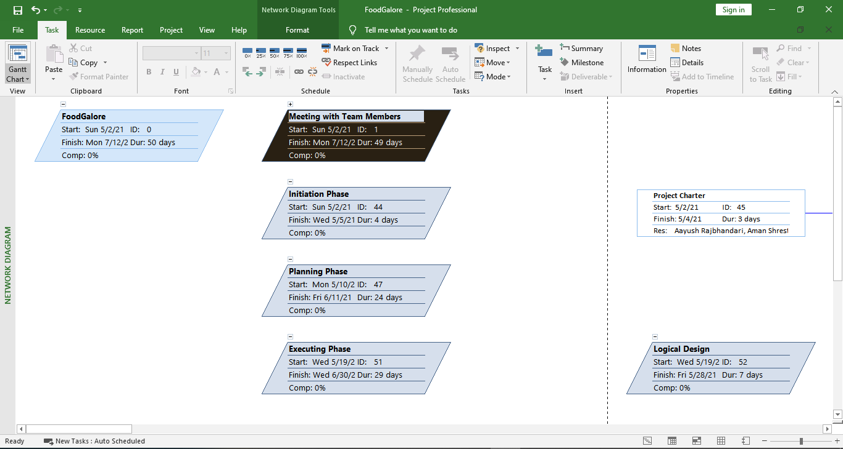

**Task Sheet**

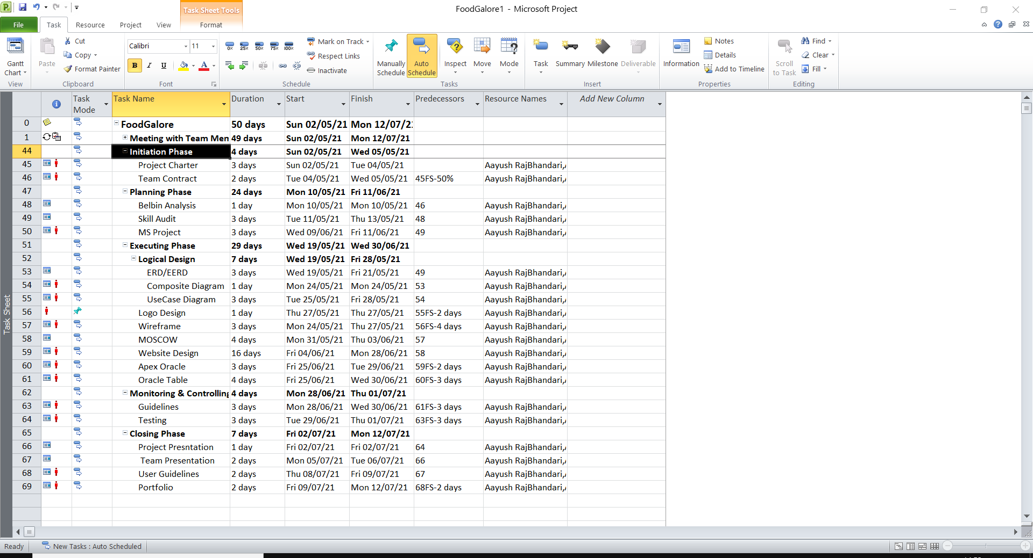

**Calendar**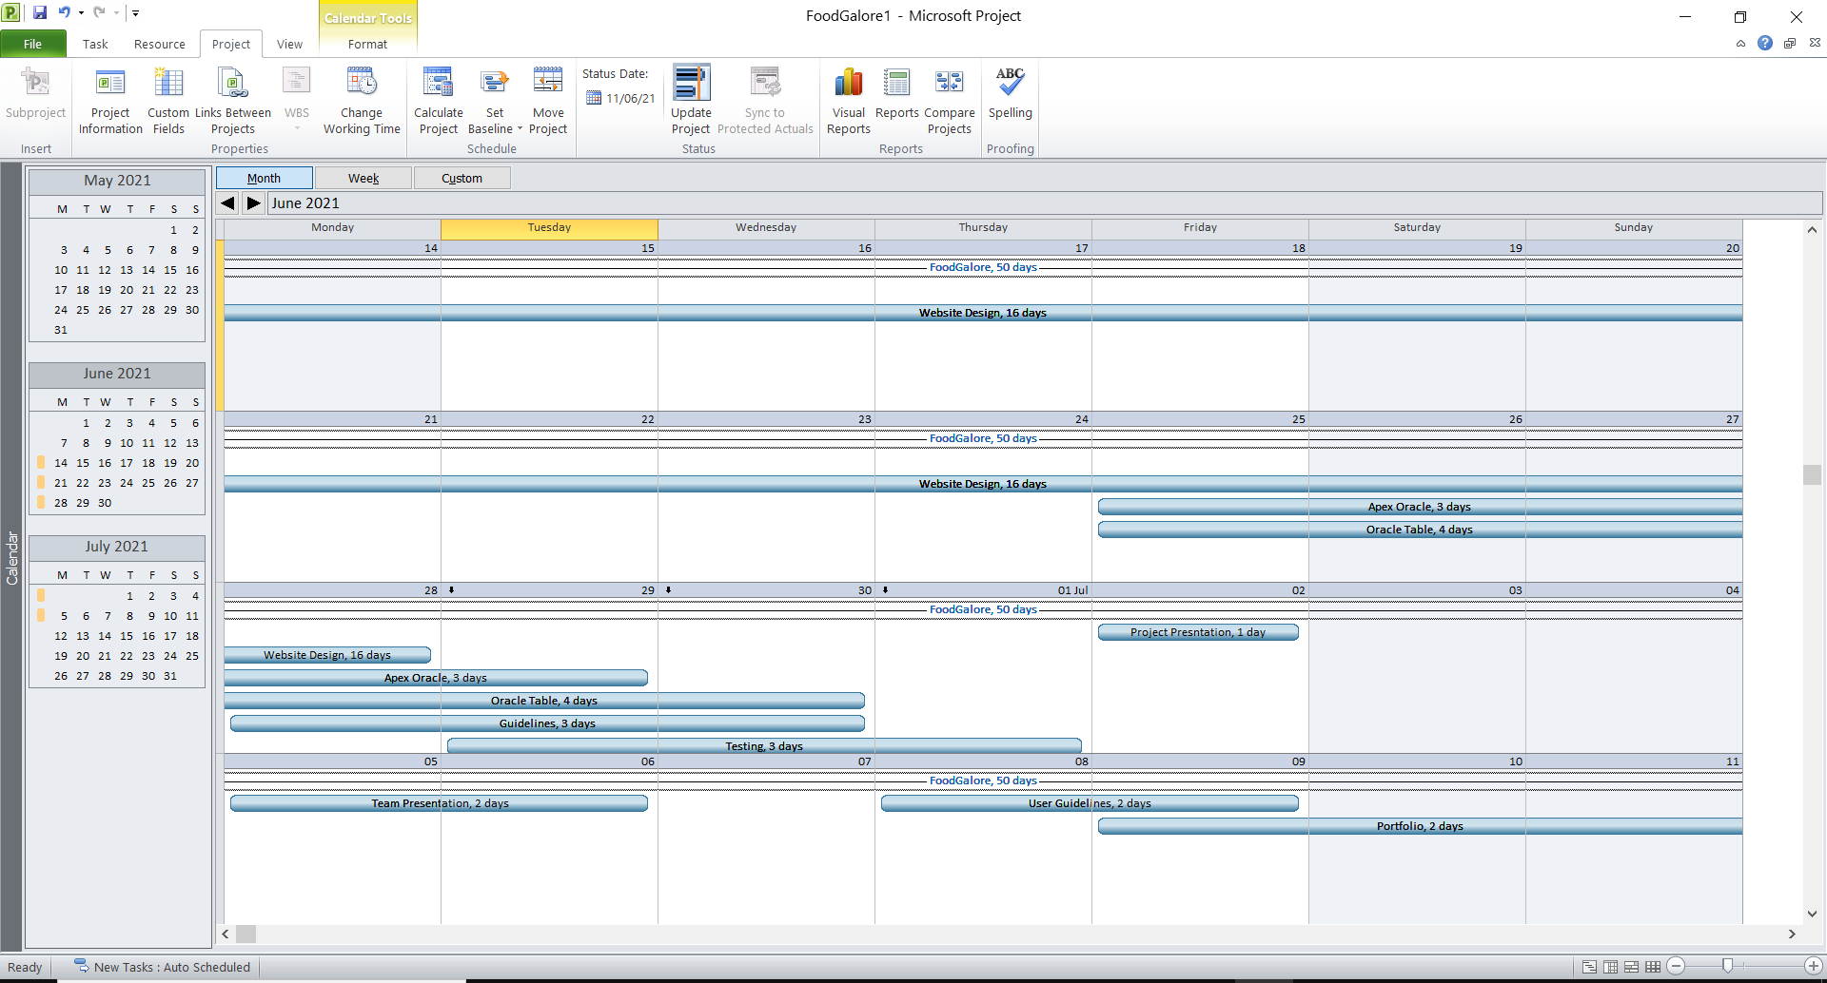

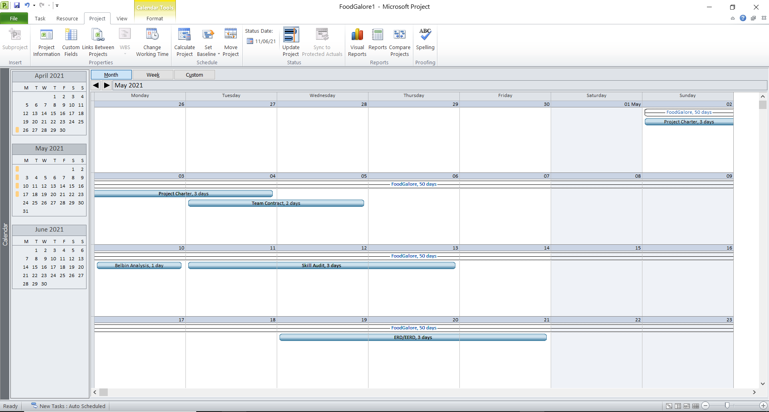



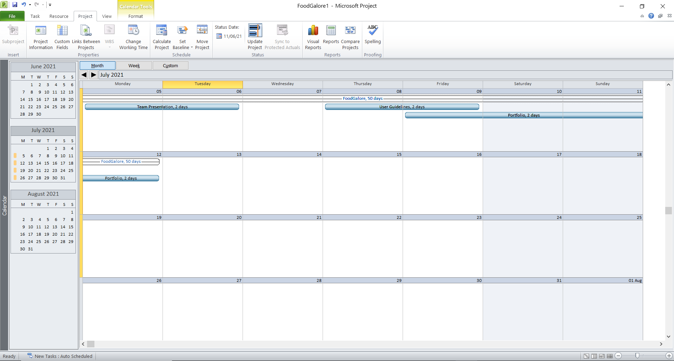

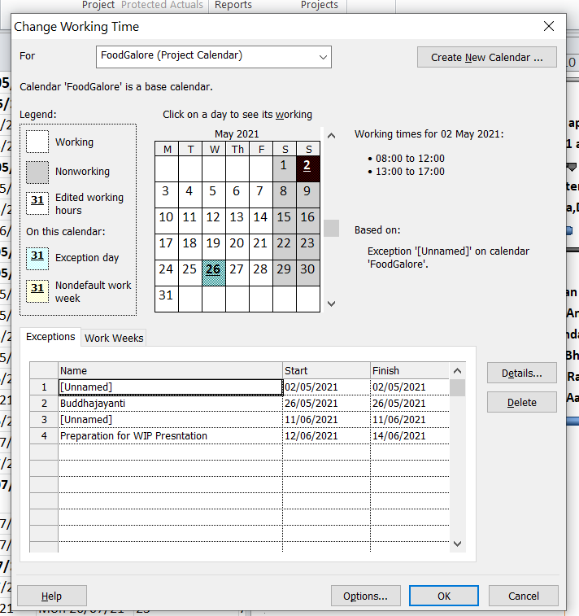

**Resource Sheet**

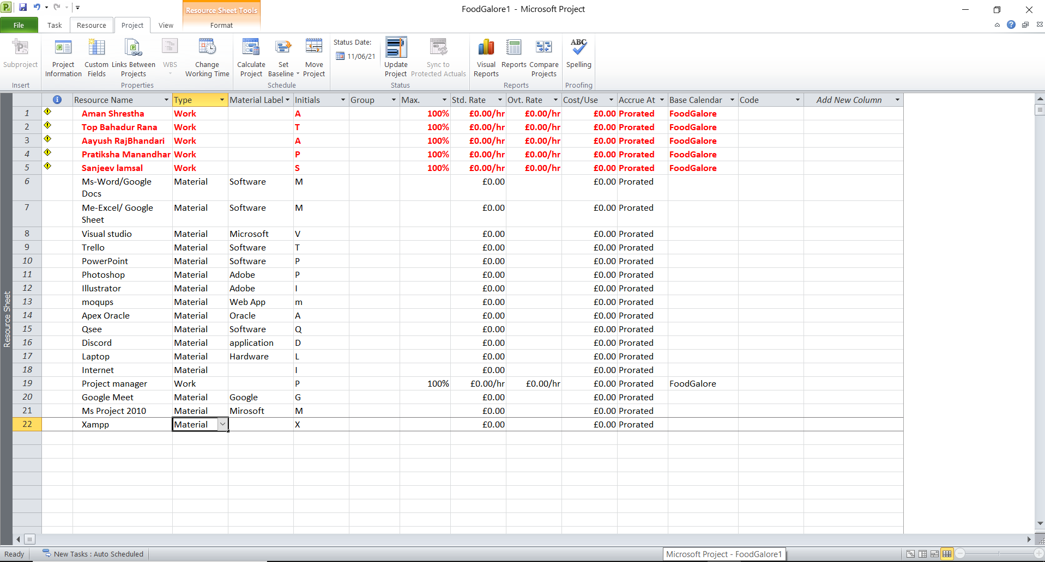

**2.4 Communication Tools Used**

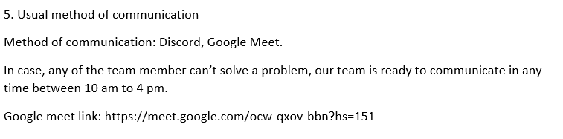

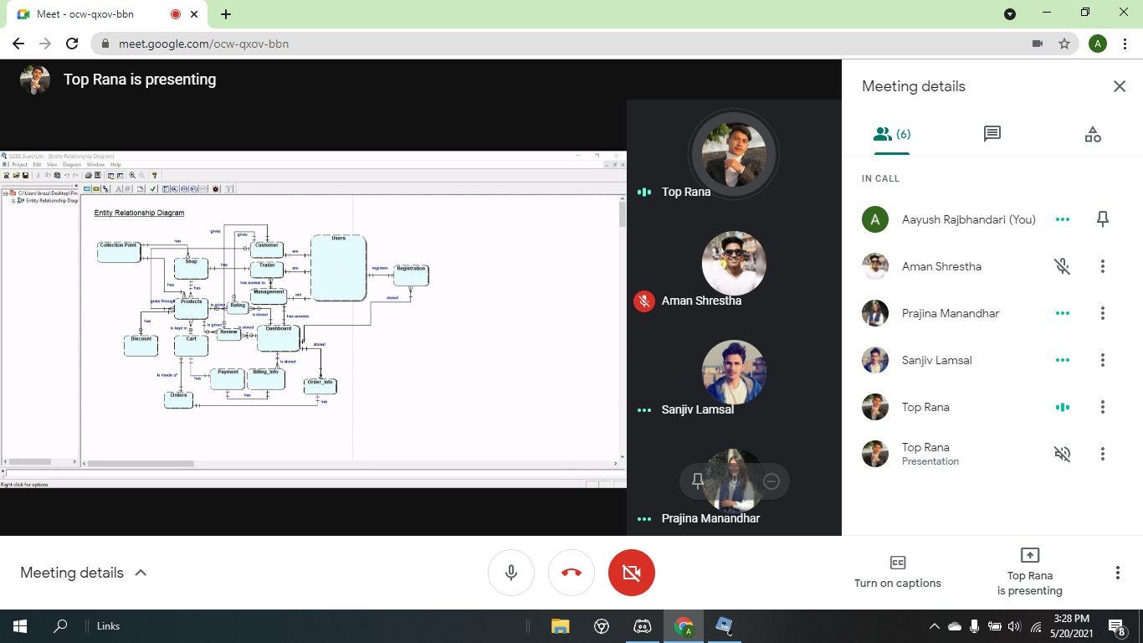

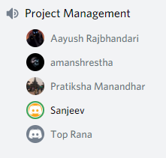

**Execution phase**

**3.1 Entity Relationship Diagram**

**EERD, ERD, Composite , Logital Table screenshot**

ERD

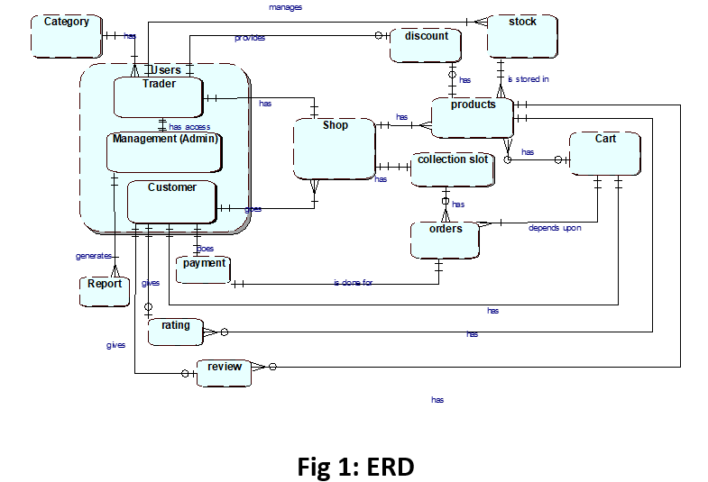

**EERD**

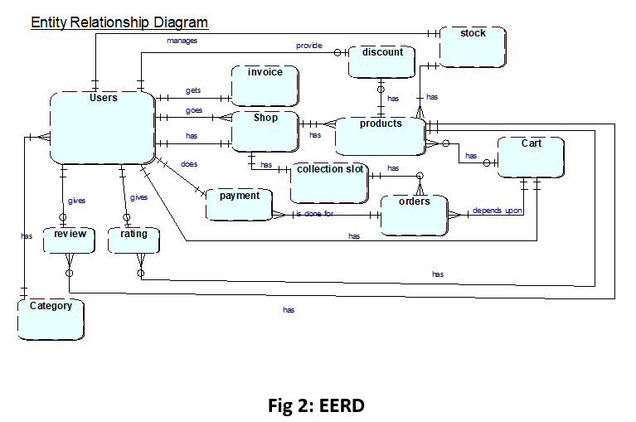

**EERD Composite**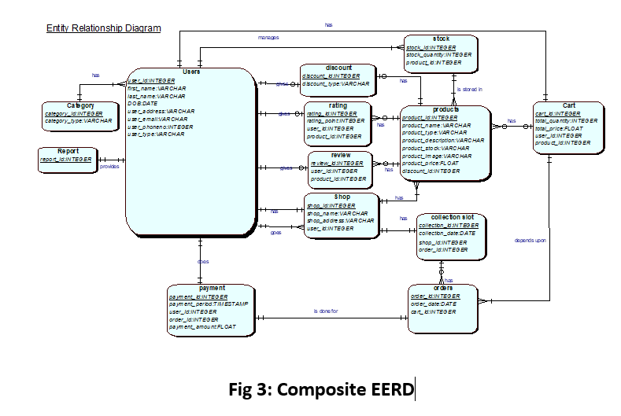

**Logical Table**

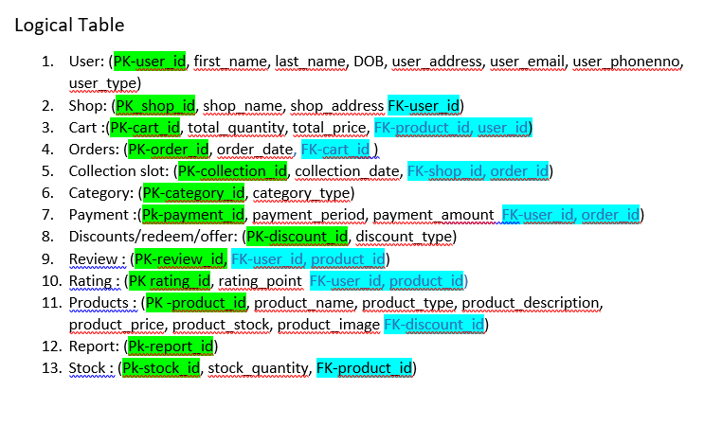

**3.2 Use Case Diagram**

**Customer**

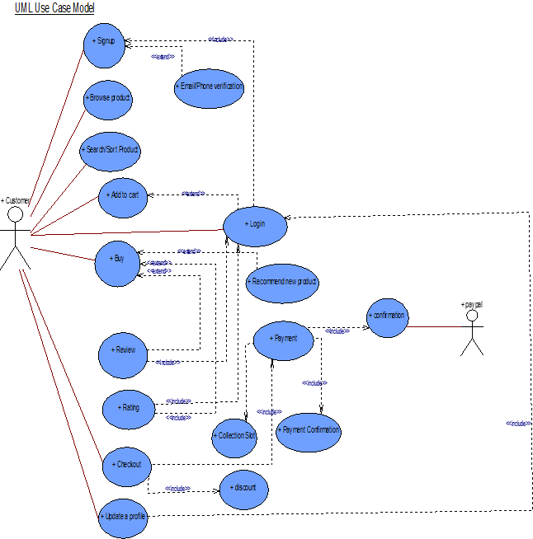

**Admin**

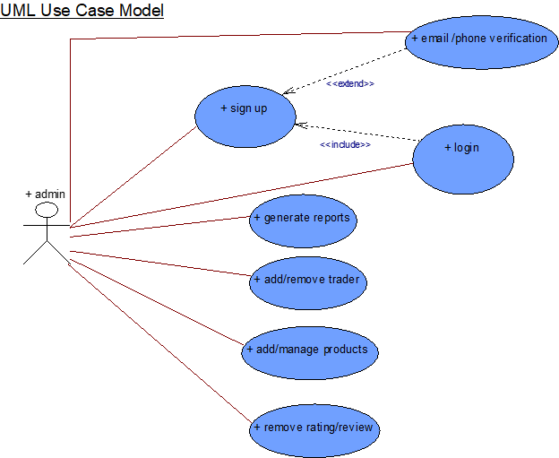

**Trader**

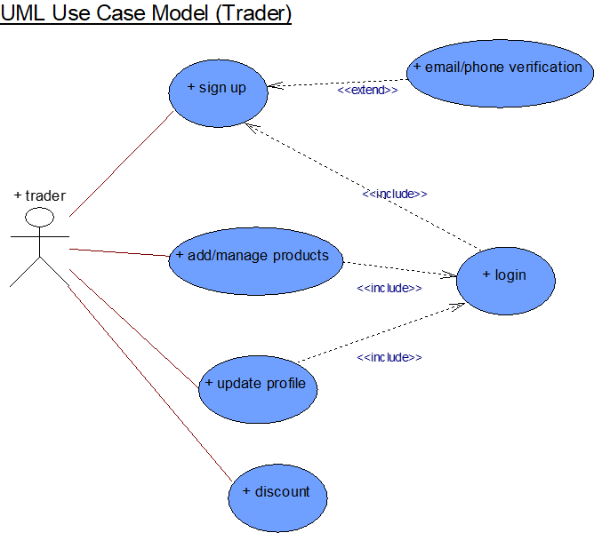

**Overview**

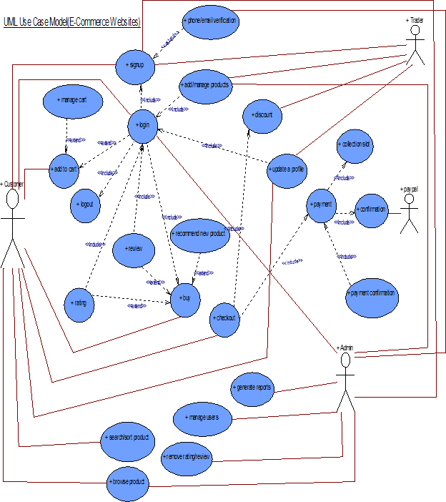

**3.3 Requirement Catalogue (Functional Requirement)  
All four interface screenshots  
A. Products**

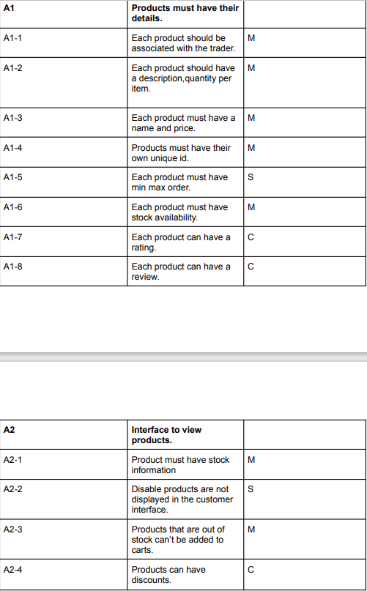

**B. Customer**

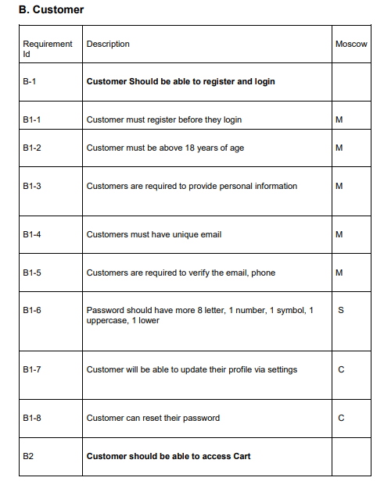

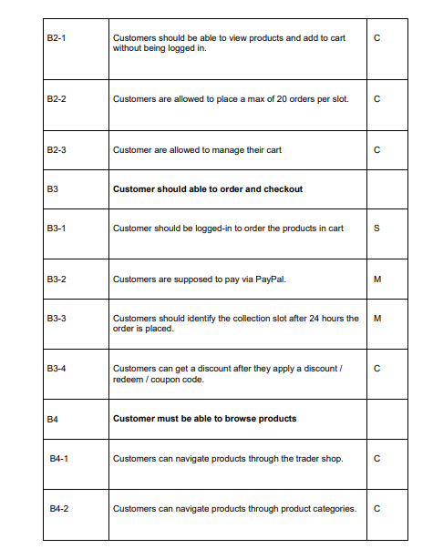

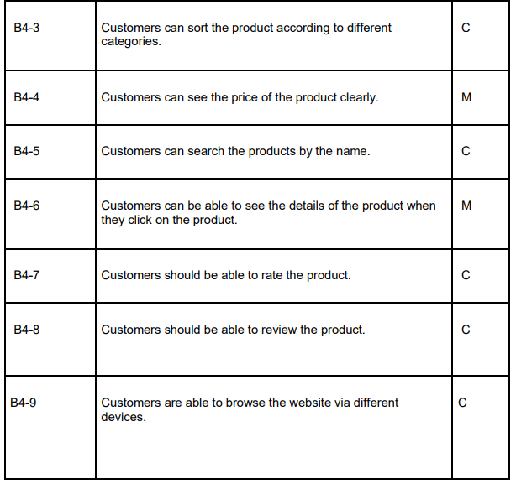

**C. Trader**

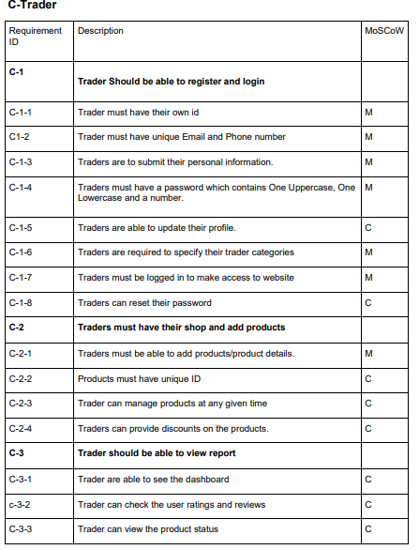

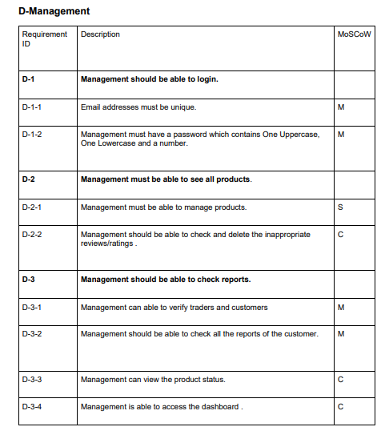

**Non-functional Requirement**

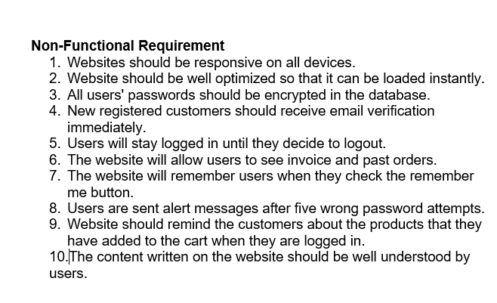

**3.4 Logo design**



**3.5 Wireframe**

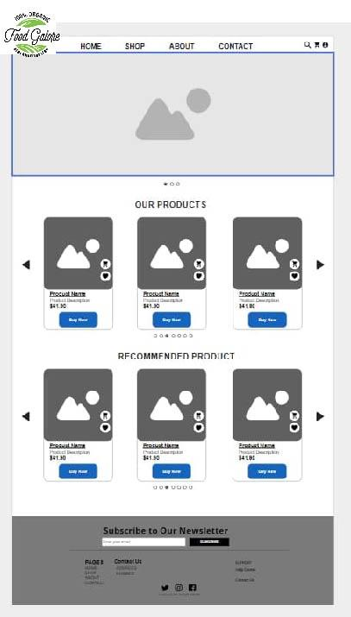

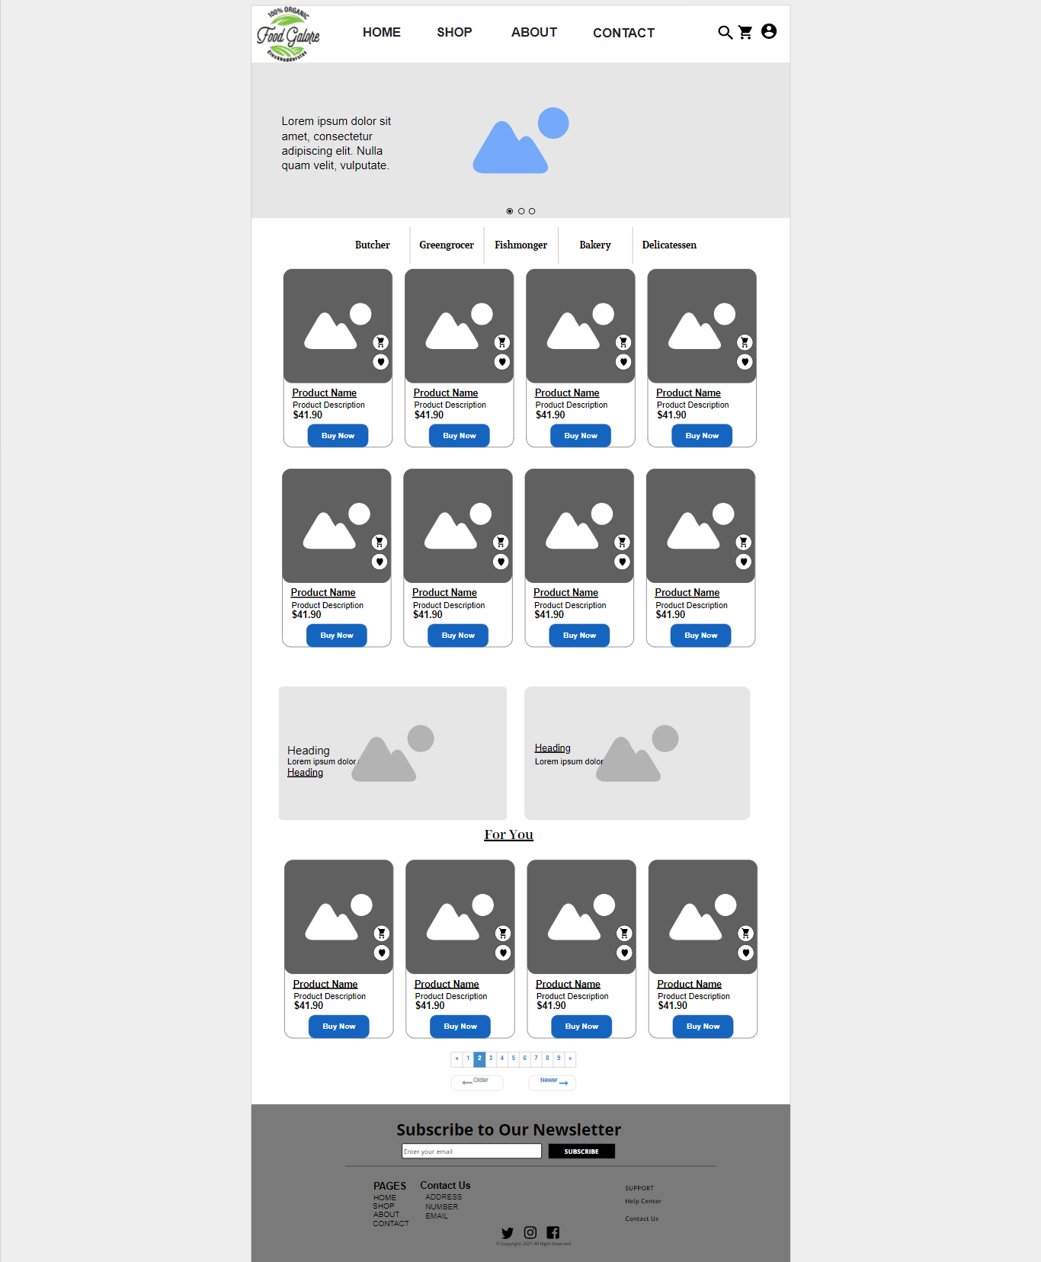

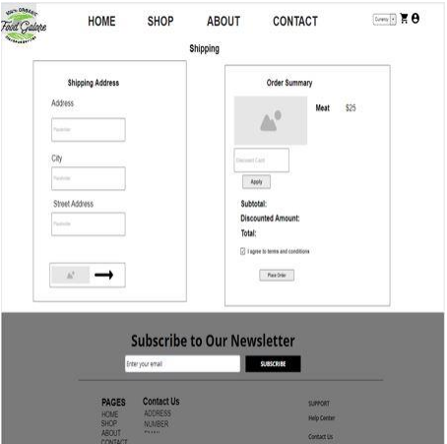

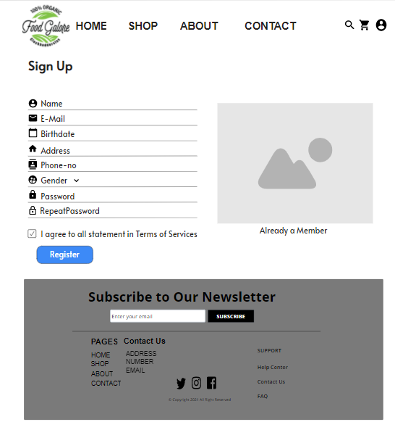

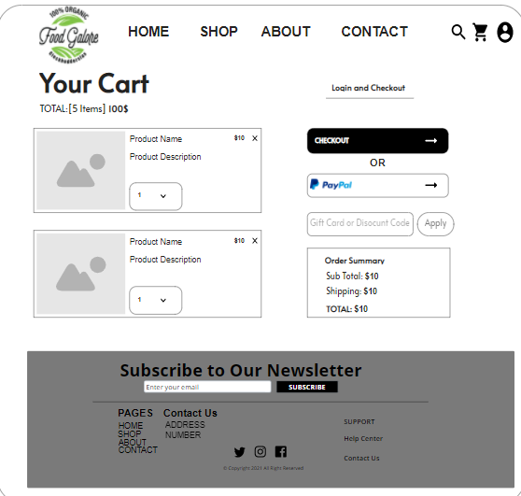



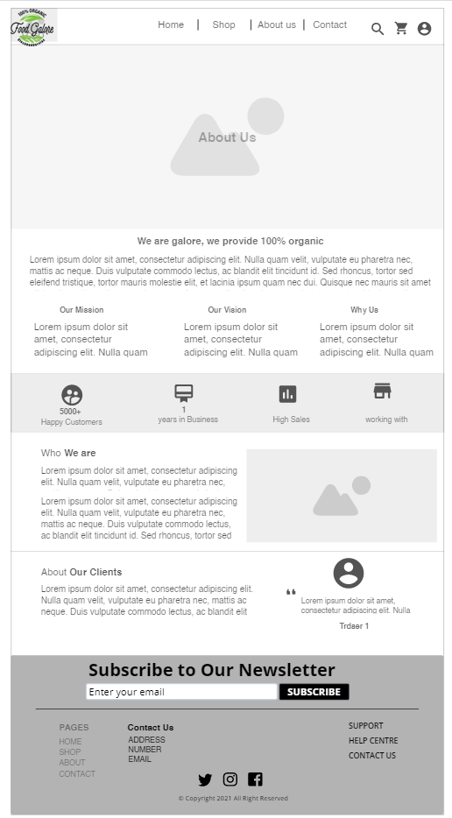



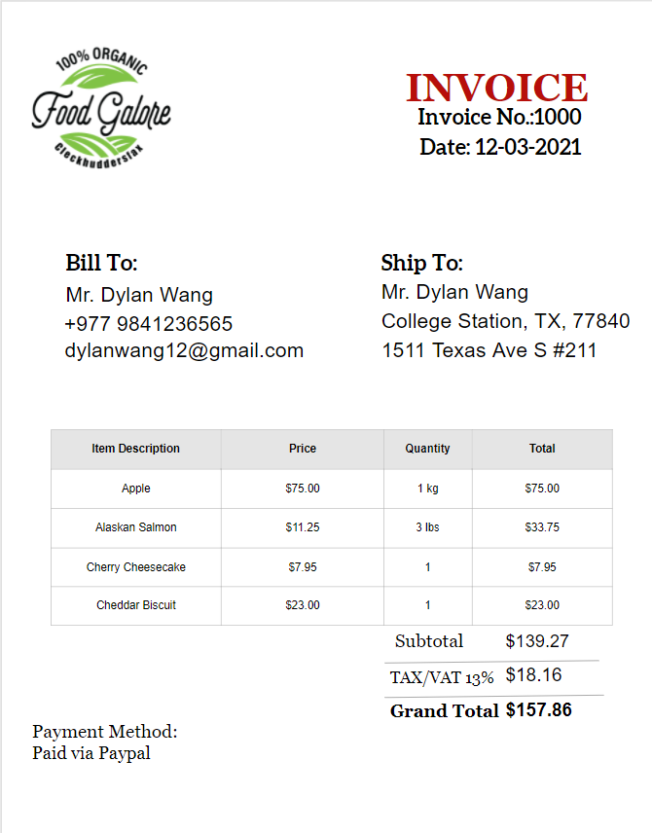

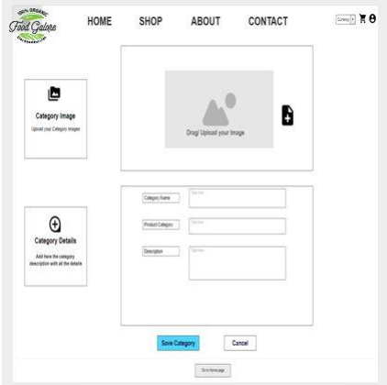

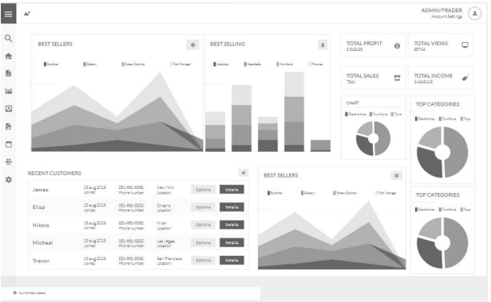

**Product Development**

**Home Page**

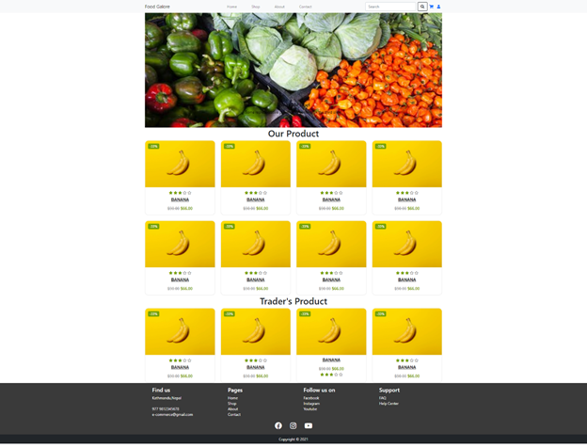

**Sign Up Page**

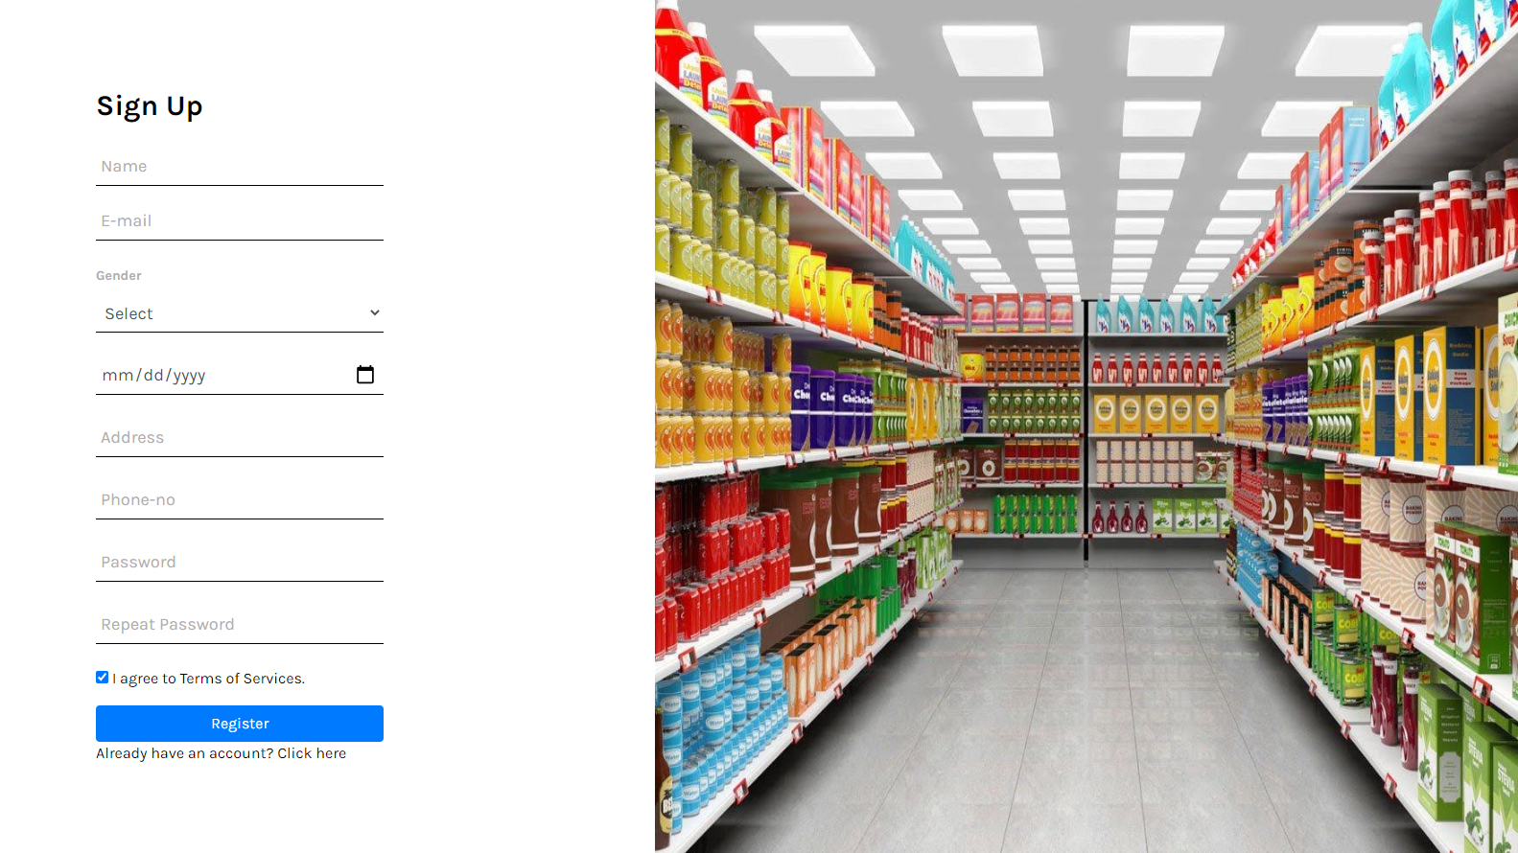

**About Us Page  
**

**Sign In Page**

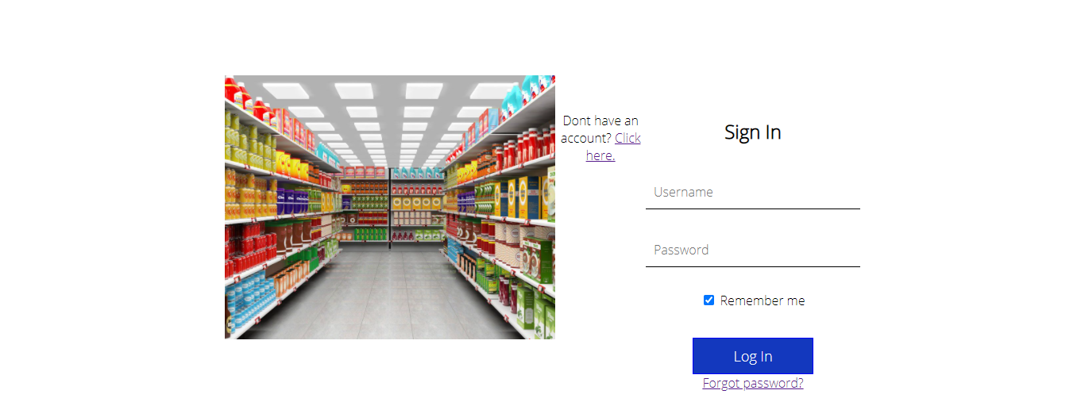

**Shop Page**

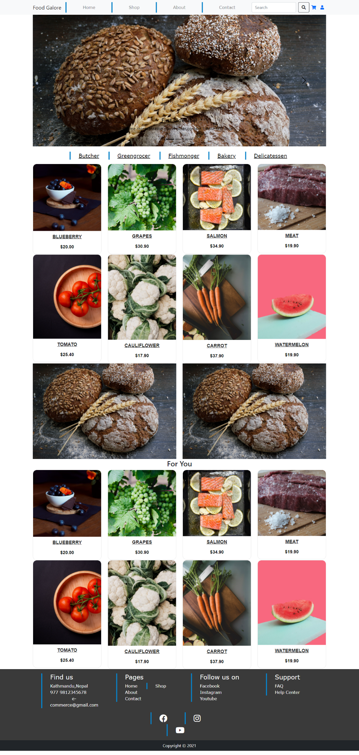

**Product Development**

**Screenshots:**





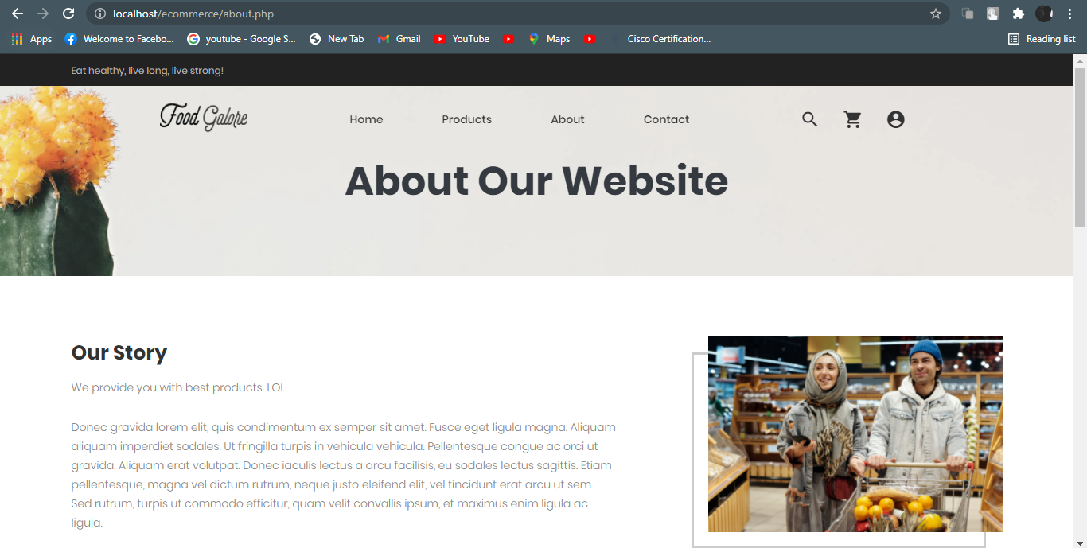

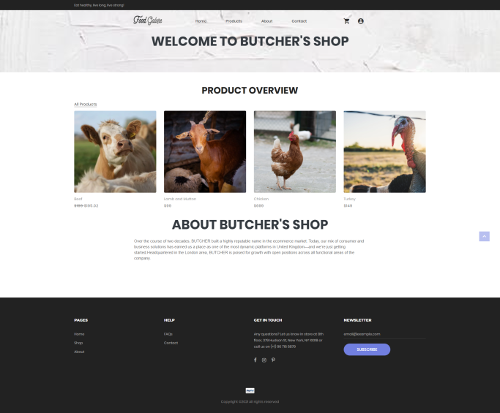

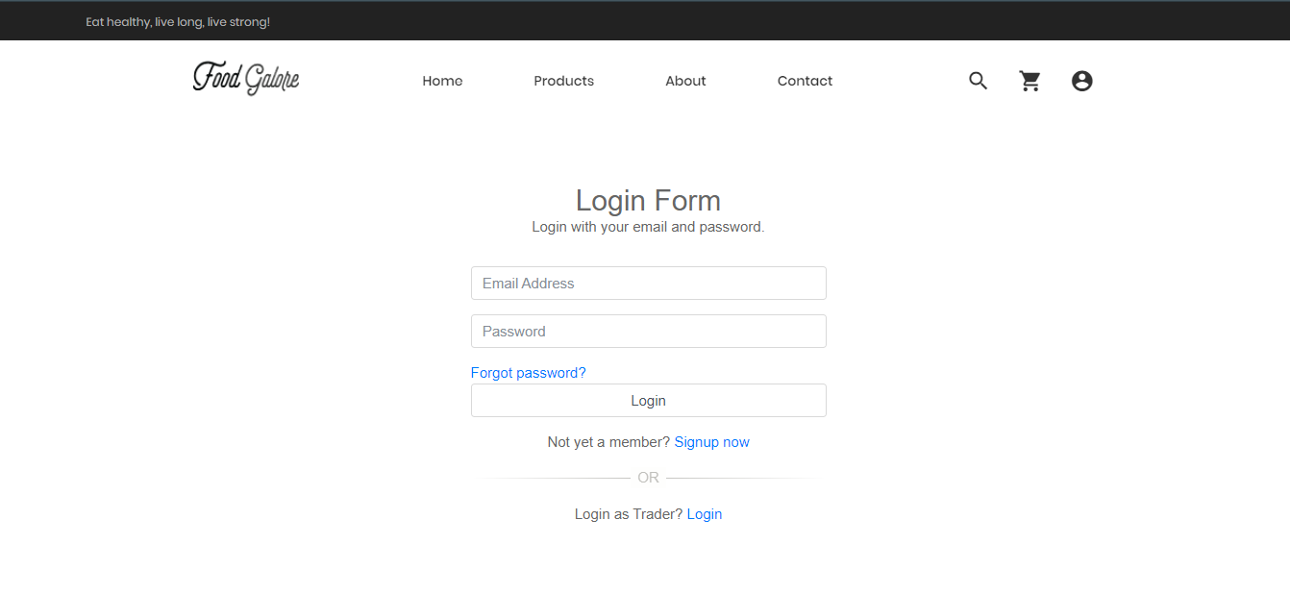

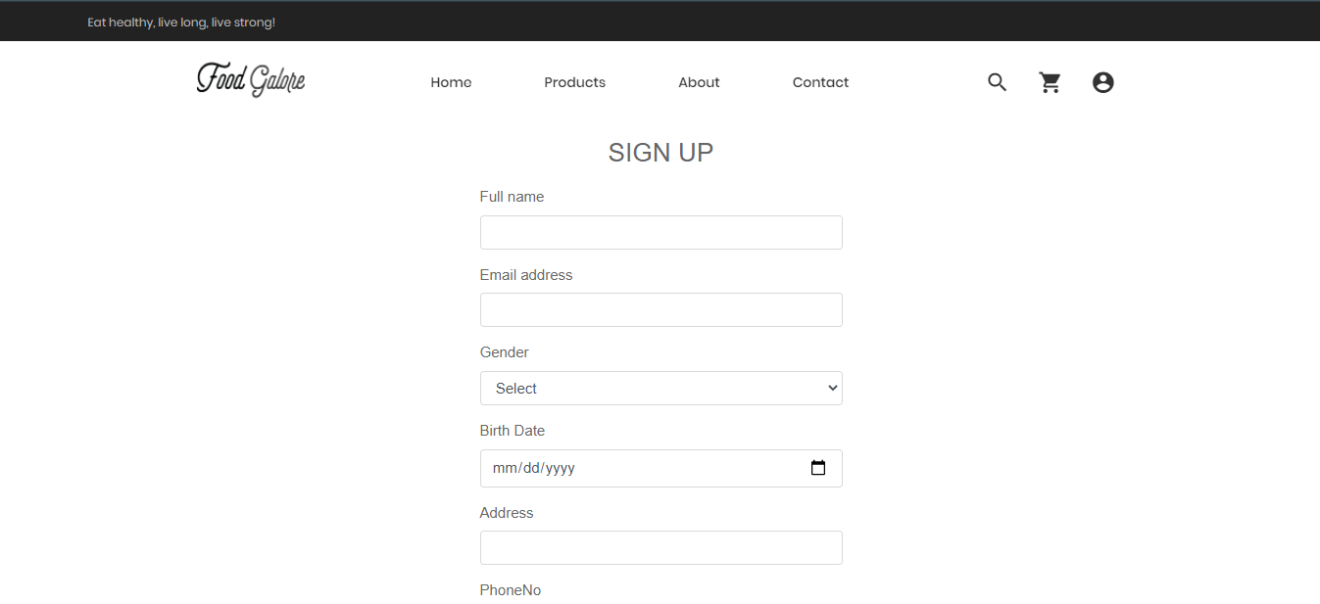

**Product Testing**

**User Interface Testing**

**1.**

Action: Go to the log-in page

Steps: Click on login page

Expected Results: Login page appears.

Pass/Fail: Pass

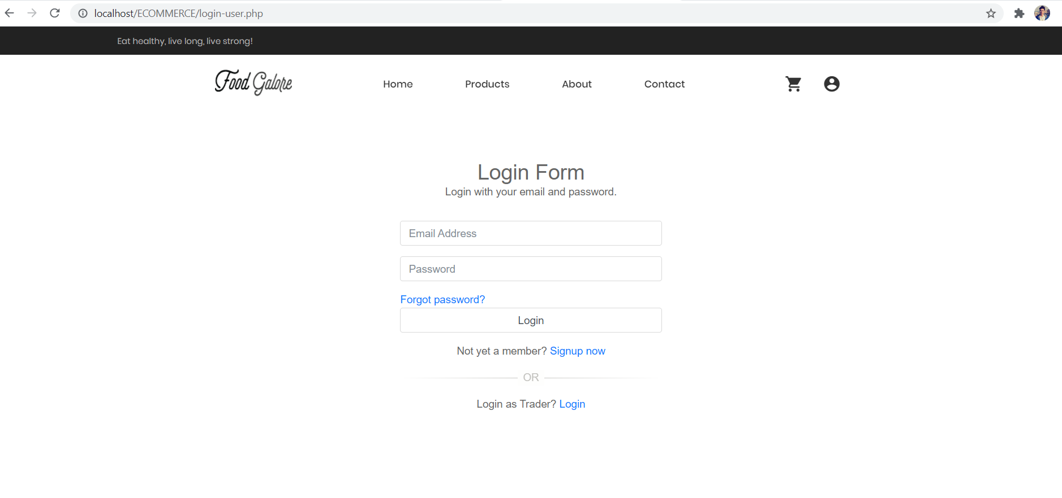

Action: Incorrect password

Steps: Input wrong login details.

Expected Results: Incorrect email and password message pops up.

Pass/Fail:Pass

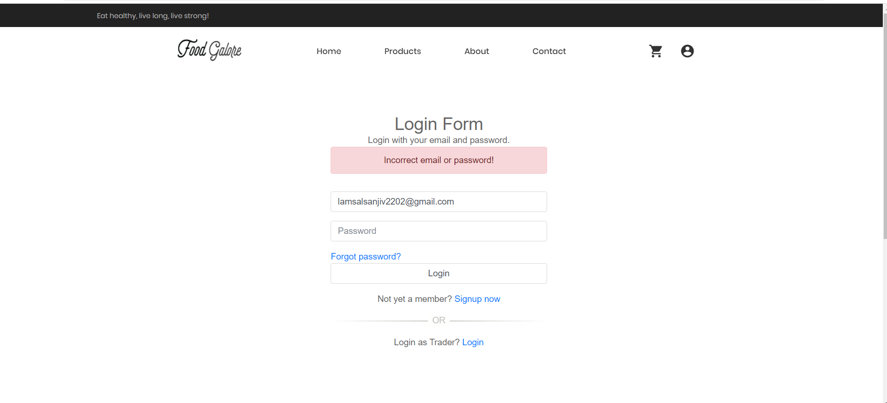

Action: Sign up

Steps: Click on signup now after clicking on the login page.

Expected Results: Signup page appears.

Pass/Fail:Pass

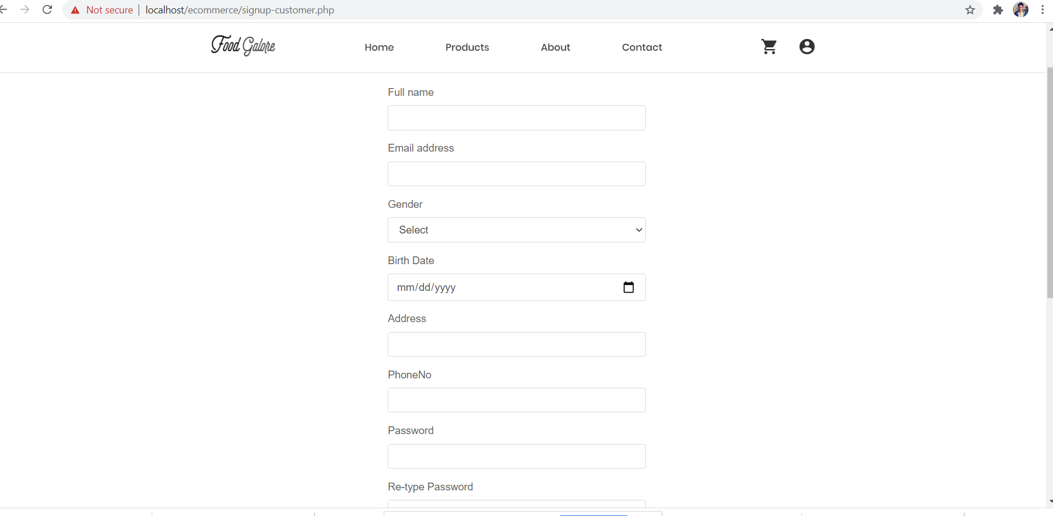

Action: Password repeat error

Steps: Input non matching passwords.

Expected Results:Passwords don't match, message pops up.

Pass/Fail: Pass

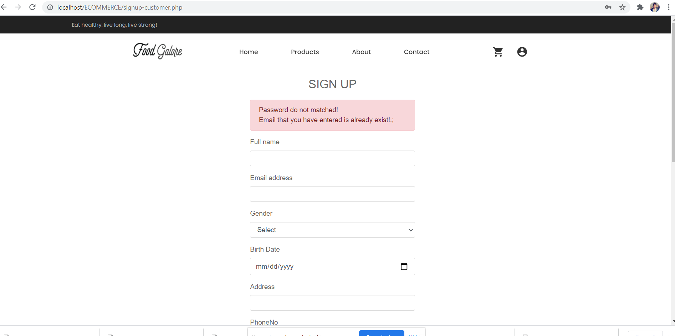

Action: Correct password and email sign up

Steps: Fill all details correctly.

Expected Results: Verification code page appears.

Pass/Fail:Pass

Action: Verification code

Steps: Filling all details correctly in signup page

Expected Results

Pass/Fail: Pass

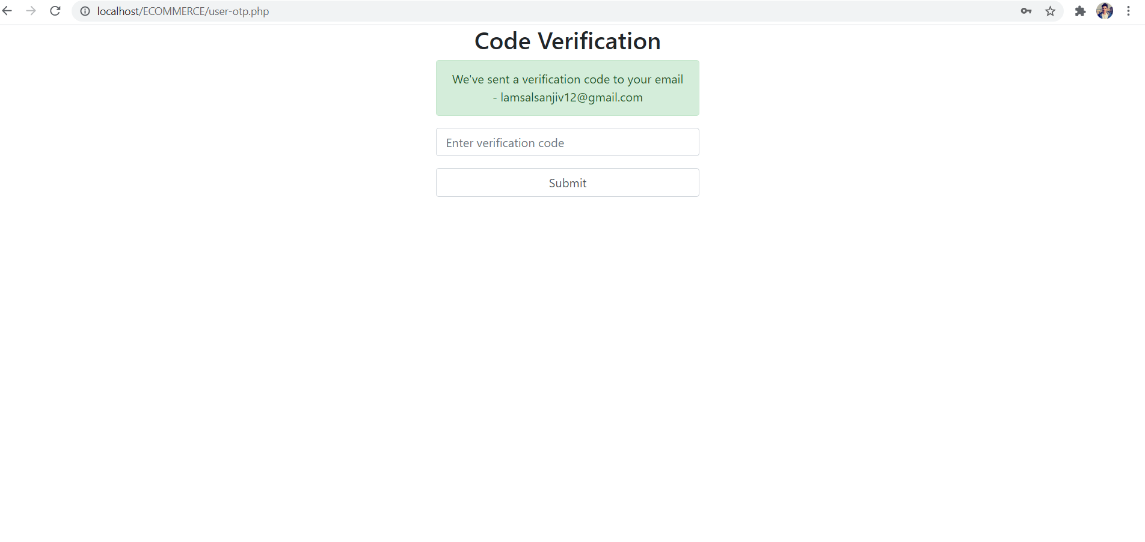

Action: Email verification code

Steps: Open email and check verification code.

Expected Results: Verification code appears.

Pass/Fail: Pass

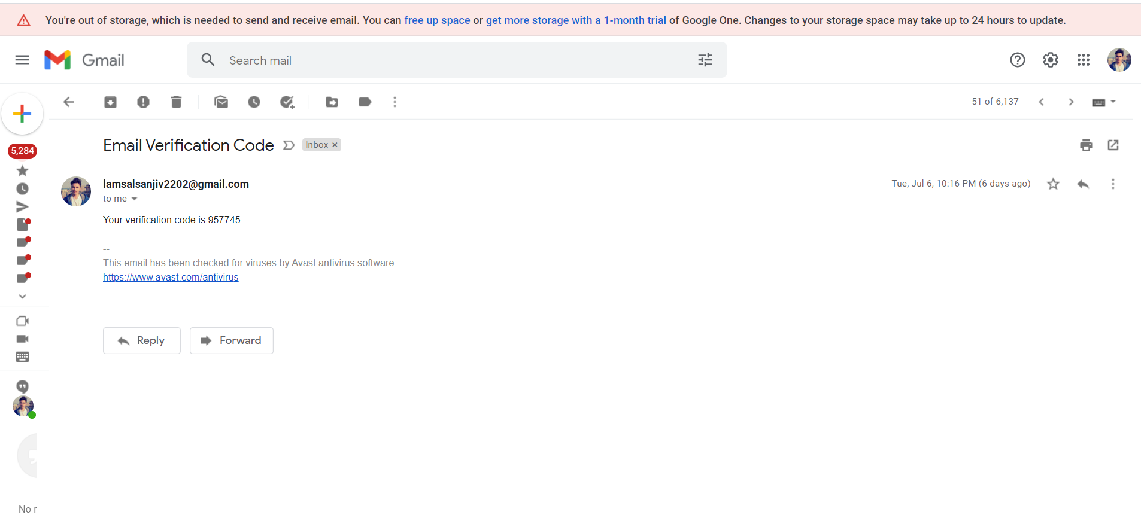

Action: Homepage

Steps: Open website

Expected Results:Homepage opens up.

Pass/Fail: Pass

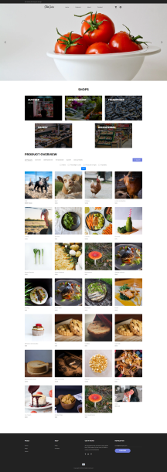

Action: Product page

Steps: Click on product page

Expected Results: Product page appears

Pass/Fail: Pass

Action: About Page

Steps: Click on about page

Expected Results:You will be directed to the us page.

Pass/Fail:Pass



Action: Contact page

Steps: Click on Contact page

Expected Results: You will be directed to contact page.

Pass/Fail:Pass

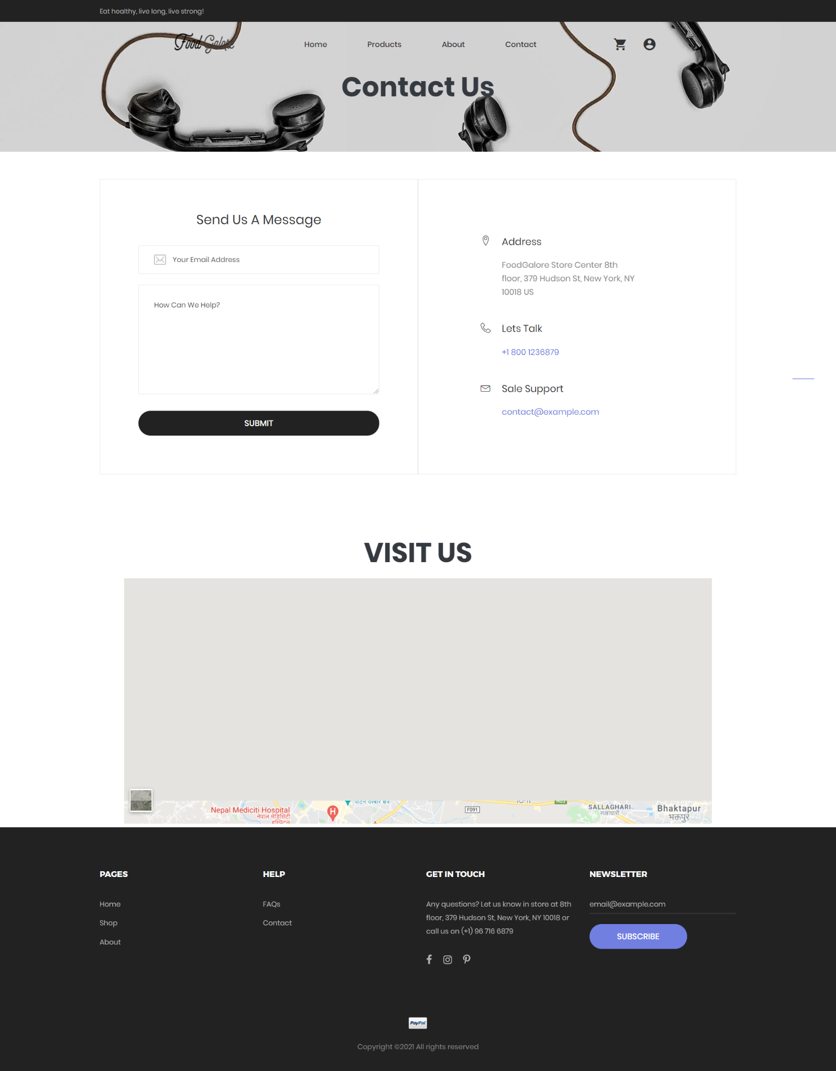

Action: Search and Sorting

Steps: Go to product page and sort according to name,price, popularity.

Expected Results: Sort appears.

Pass/Fail:Pass

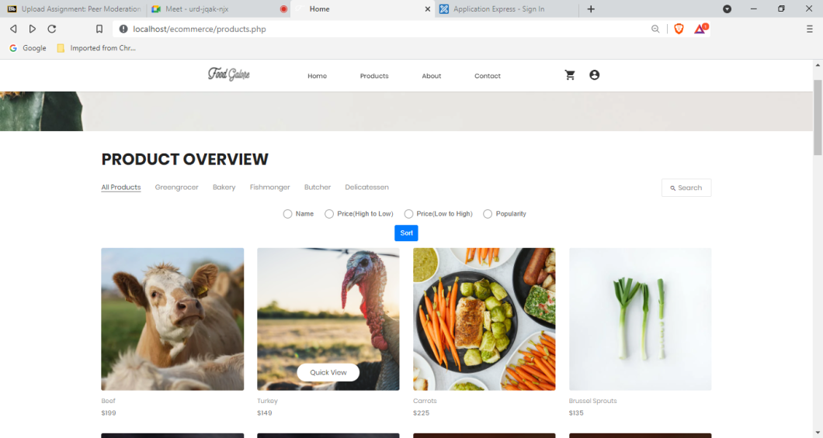

Action: FAQS

Steps: Click on faqs page.

Expected Results: You will be directed to the faq page.

Pass/Fail: Pass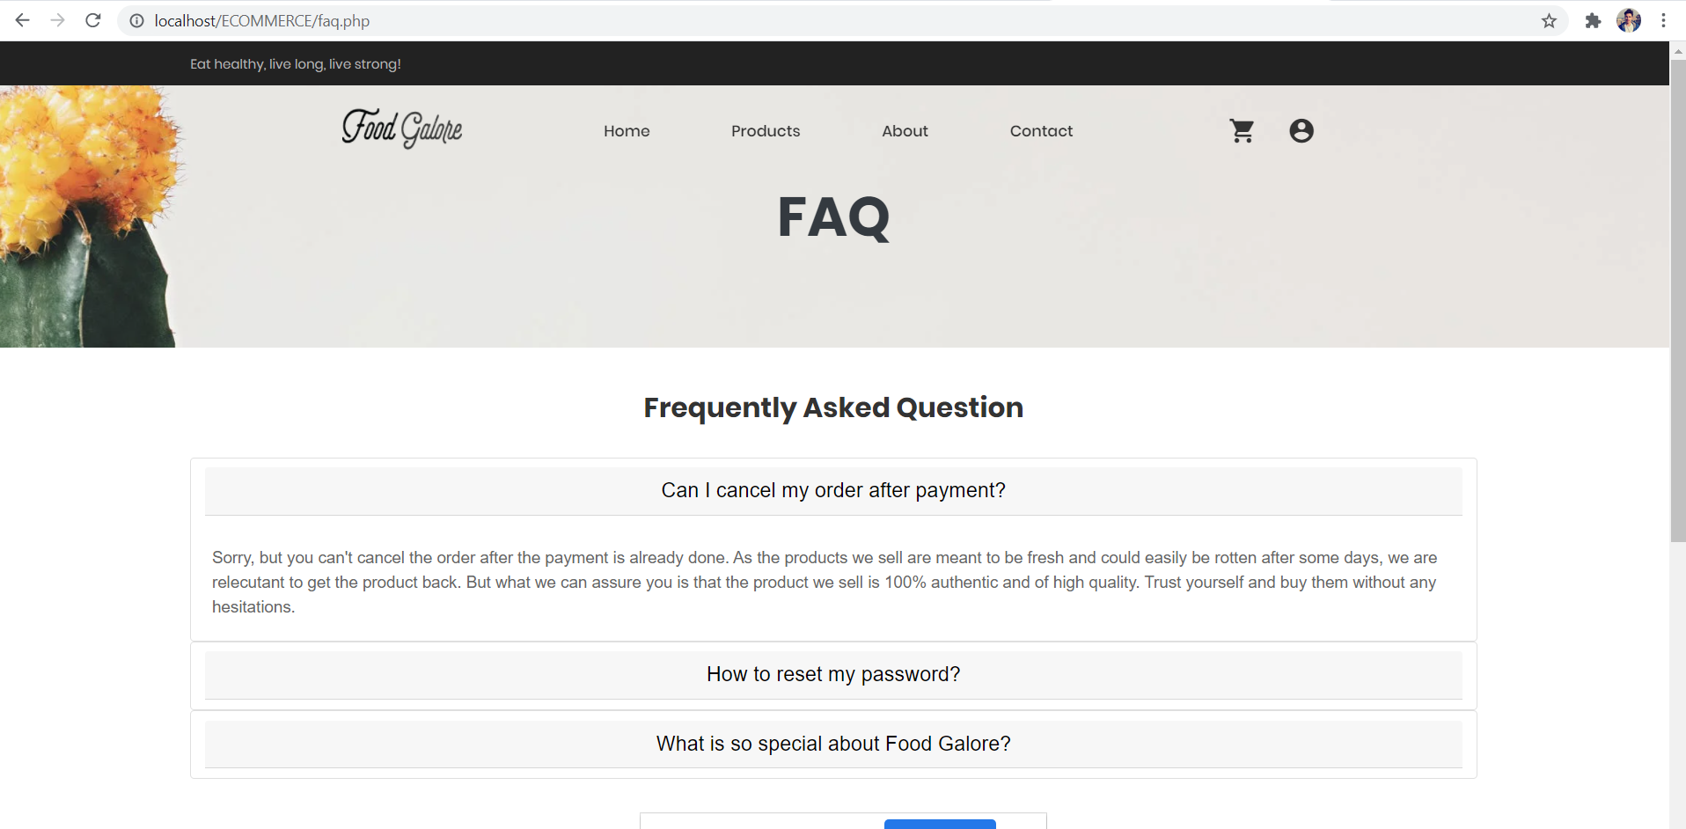

Action: Go to the Cart shown in the navigation

Steps: Click on navigation bar

Expected Results: You will be directed into Cart page

Pass/Fail: Pass

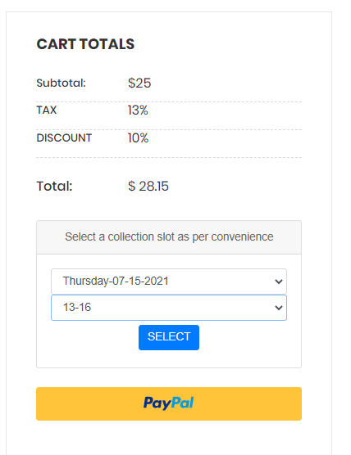

Action: Go and select your Collection Slot

Steps: Select your desirable slot and click select

Expected Results: You will have completed your payment

Pass/Fail: Pass

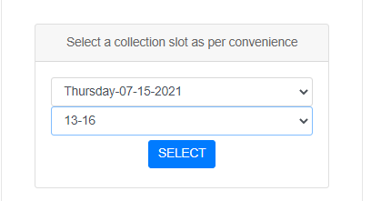

Action: Your payment will be completed

Steps: No step needed

Expected Results: A payment Success message pops up.

Pass/Fail: Pass

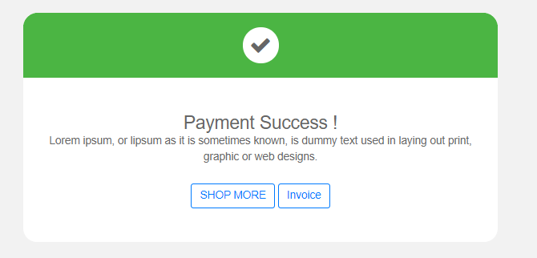

Action: When you go over to Invoice

Steps: Click on Invoice

Expected Results: Your total invoice will appear

Pass/Fail: Pass

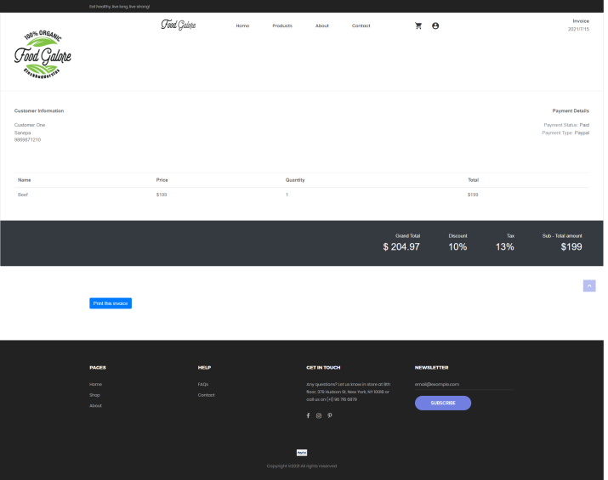

Action: Go to the Signout

Steps: Click on navigation bar and then logout

Expected Results: You will logout from the page

Pass/Fail: Pass

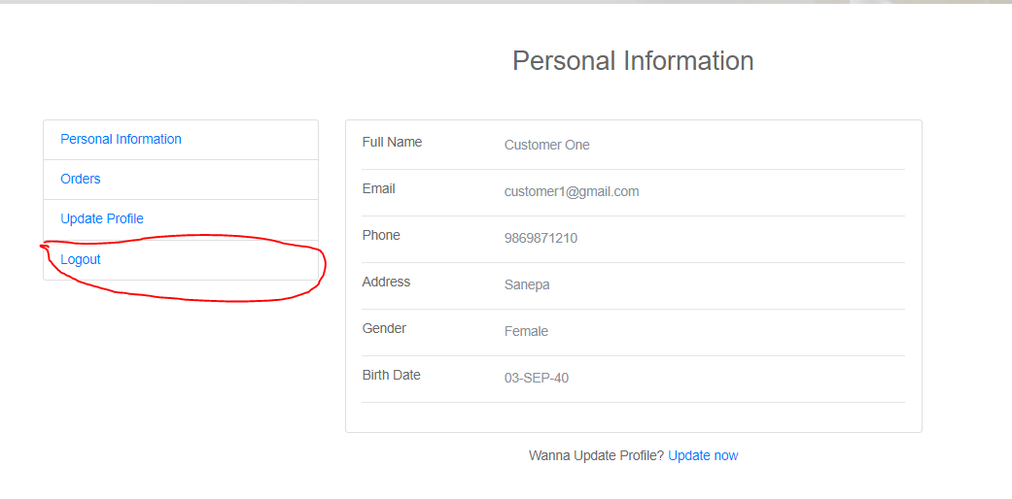

Action: View Order

Steps: Click on Order

Expected Results: You can see the orders made.

Pass/Fail: Pass

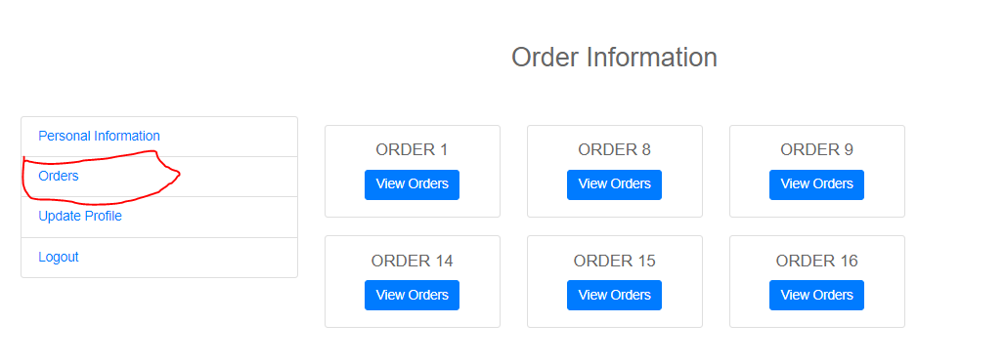

Action:View Update Profile

Steps: Go to Update Profile

Expected Results: You can Update your information

Pass/Fail:Pass

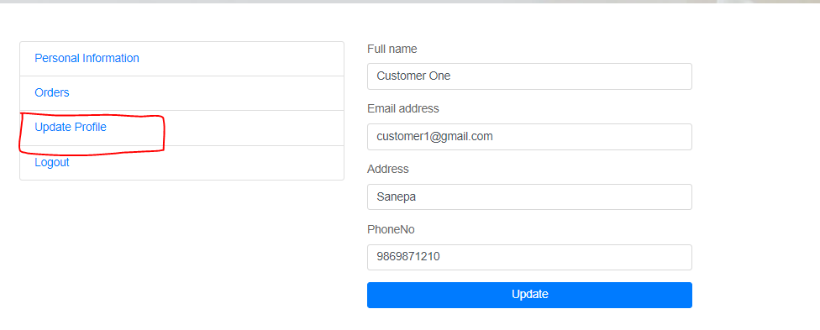

**Trader Interface Testing**

**Trader PHP**

1. SignUp

Action: Signup with incomplete fields

Steps:Click on navigation bar

Expected results: "Please fill out this field" message pops up.

Pass/Fail: Pass

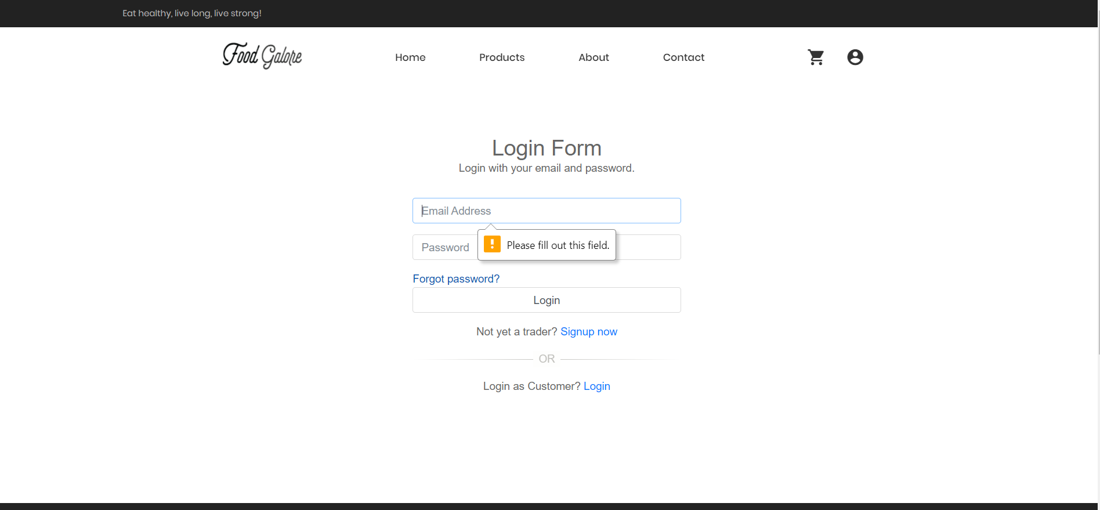

Action:Signup with email.

Steps: After signing up, a verification code is sent.

Expected results: Verification code is sent to the email.

Pass/Fail:Pass

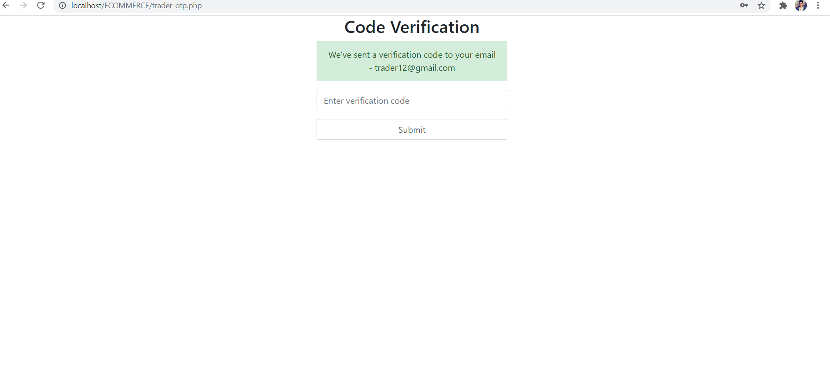

Action:Signup with wrong password or Email.

Steps: If incorrect password or Email is inserted.

Expected Results:Error message is displayed.

Pass/Fail: Pass

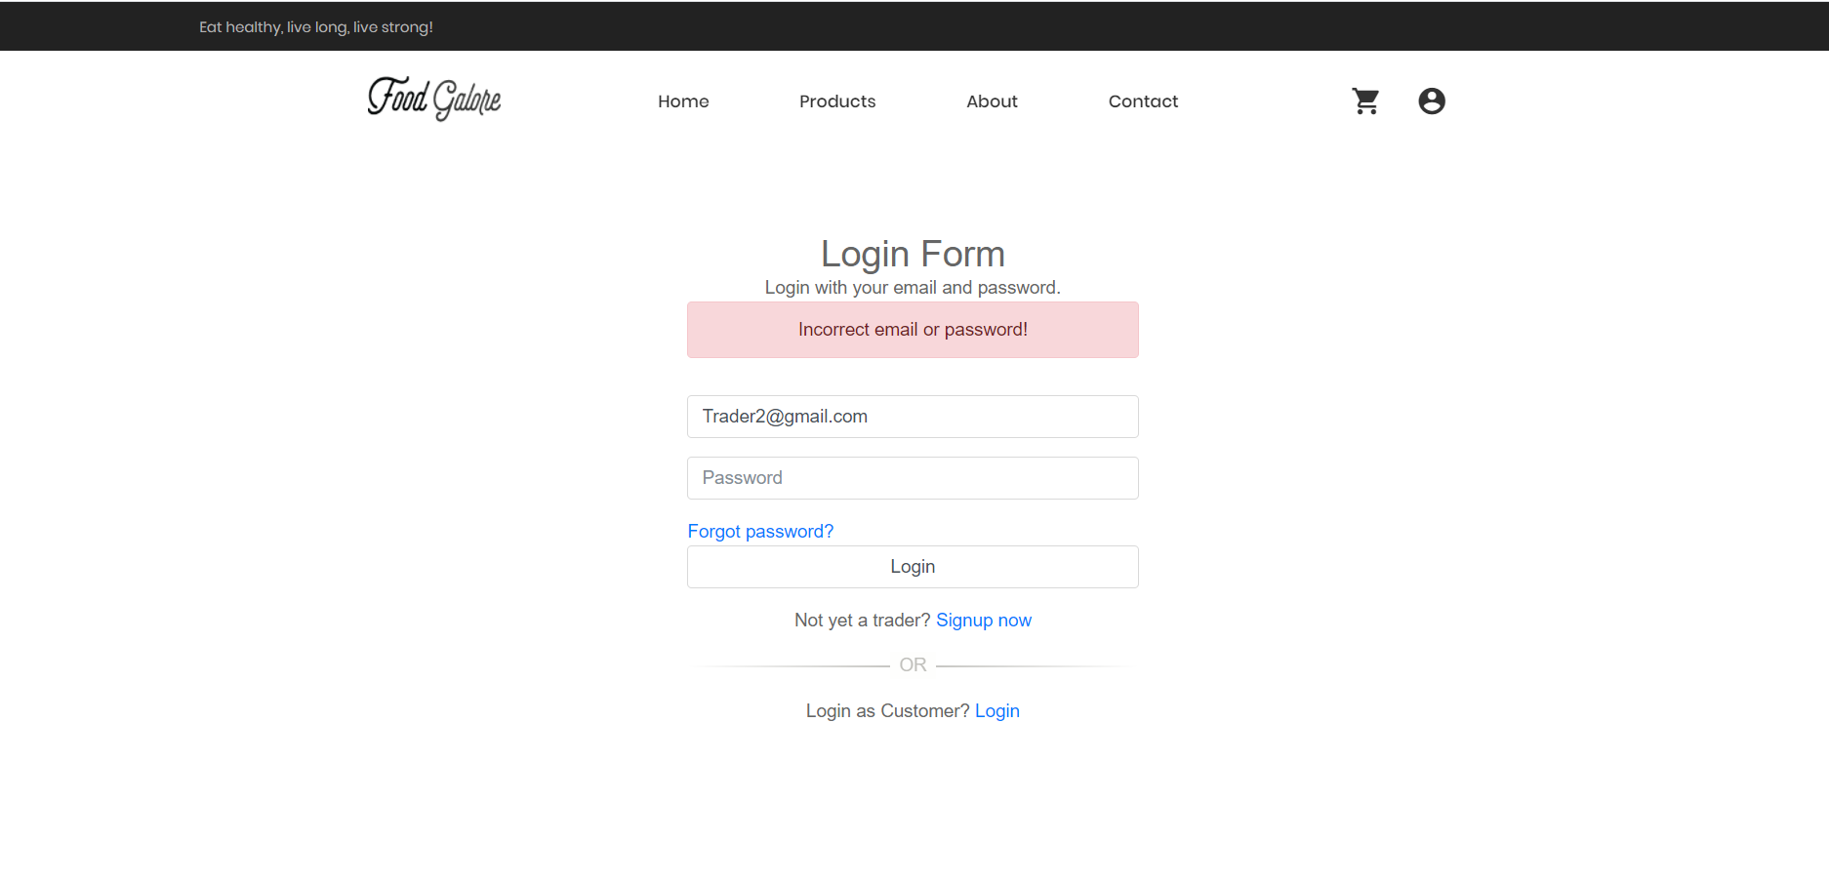

Action:Signup with wrong password in Re-type password.

Steps: After inserting password which does not match.

Expected Results:"Password doesn’t match" message is displayed.

Pass/Fail: Pass

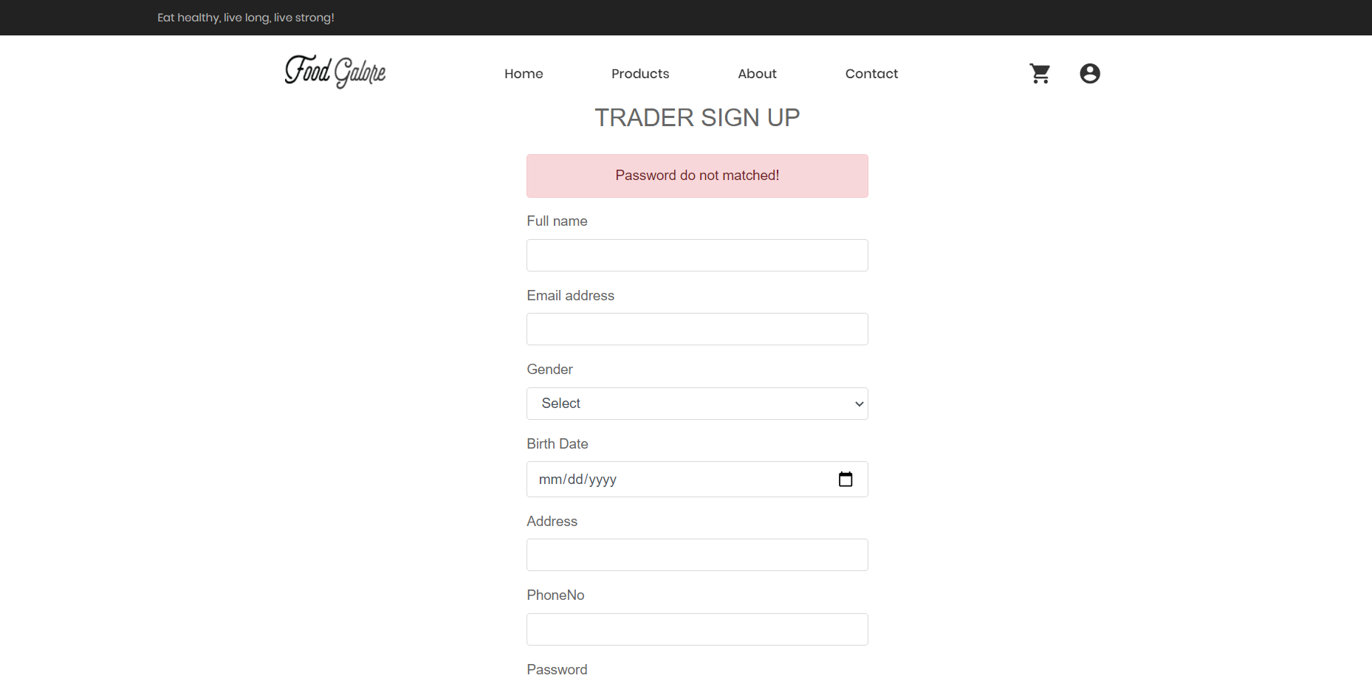

Action:Signup with all correct details.

Steps: After inserting all the correct details

Expected Results:You are signed up.

Pass/Fail: Pass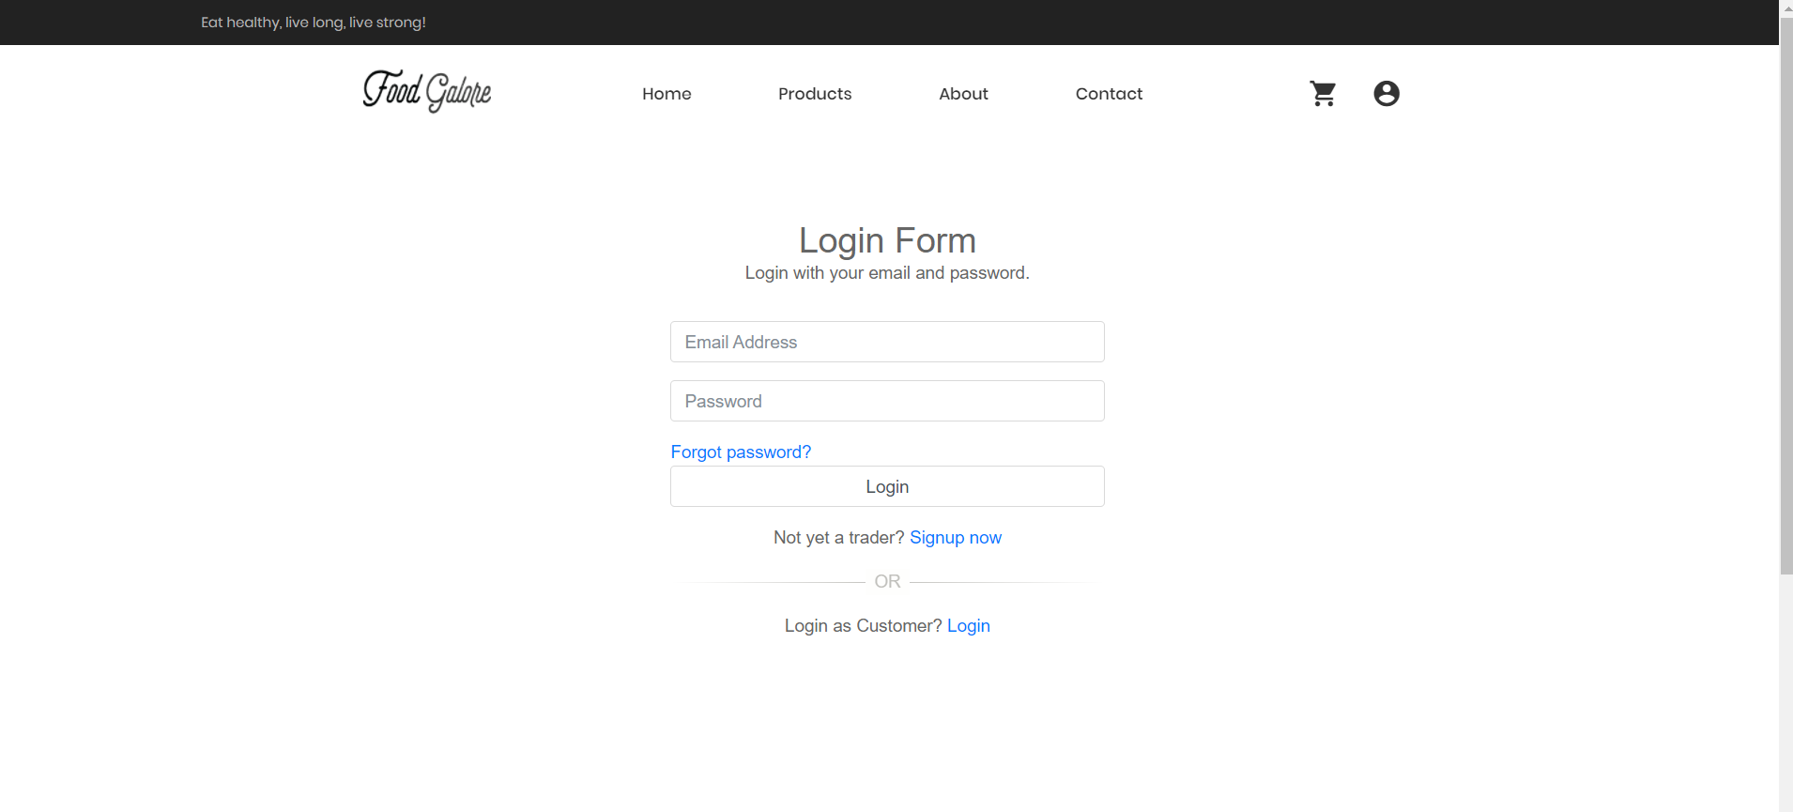

1. Login

Action:Login with correct username and password.

Steps: Click on login button.

Expected Results:You are logged in as a trader.

Pass/Fail:Pass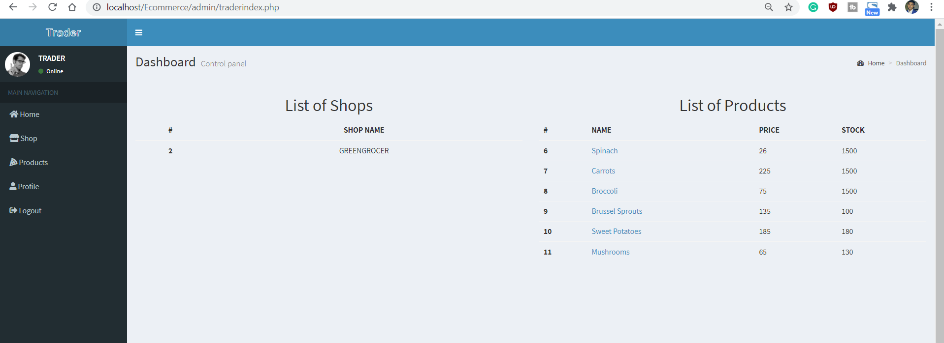

Action:Click in forgot password action.

Steps:Click on the forgot password button.

Expected Results:You are required to type your email and a verification code will be sent to that mail.

Pass/Fail:Pass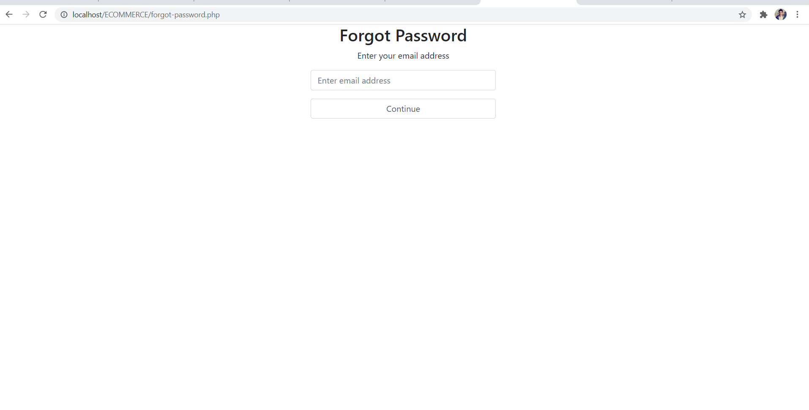

1. Personal details

Action:Personal details page.

Steps: Click on the “Account settings” icon.

Expected Results:You will be taken to the profile section.

Pass/Fail:Pass

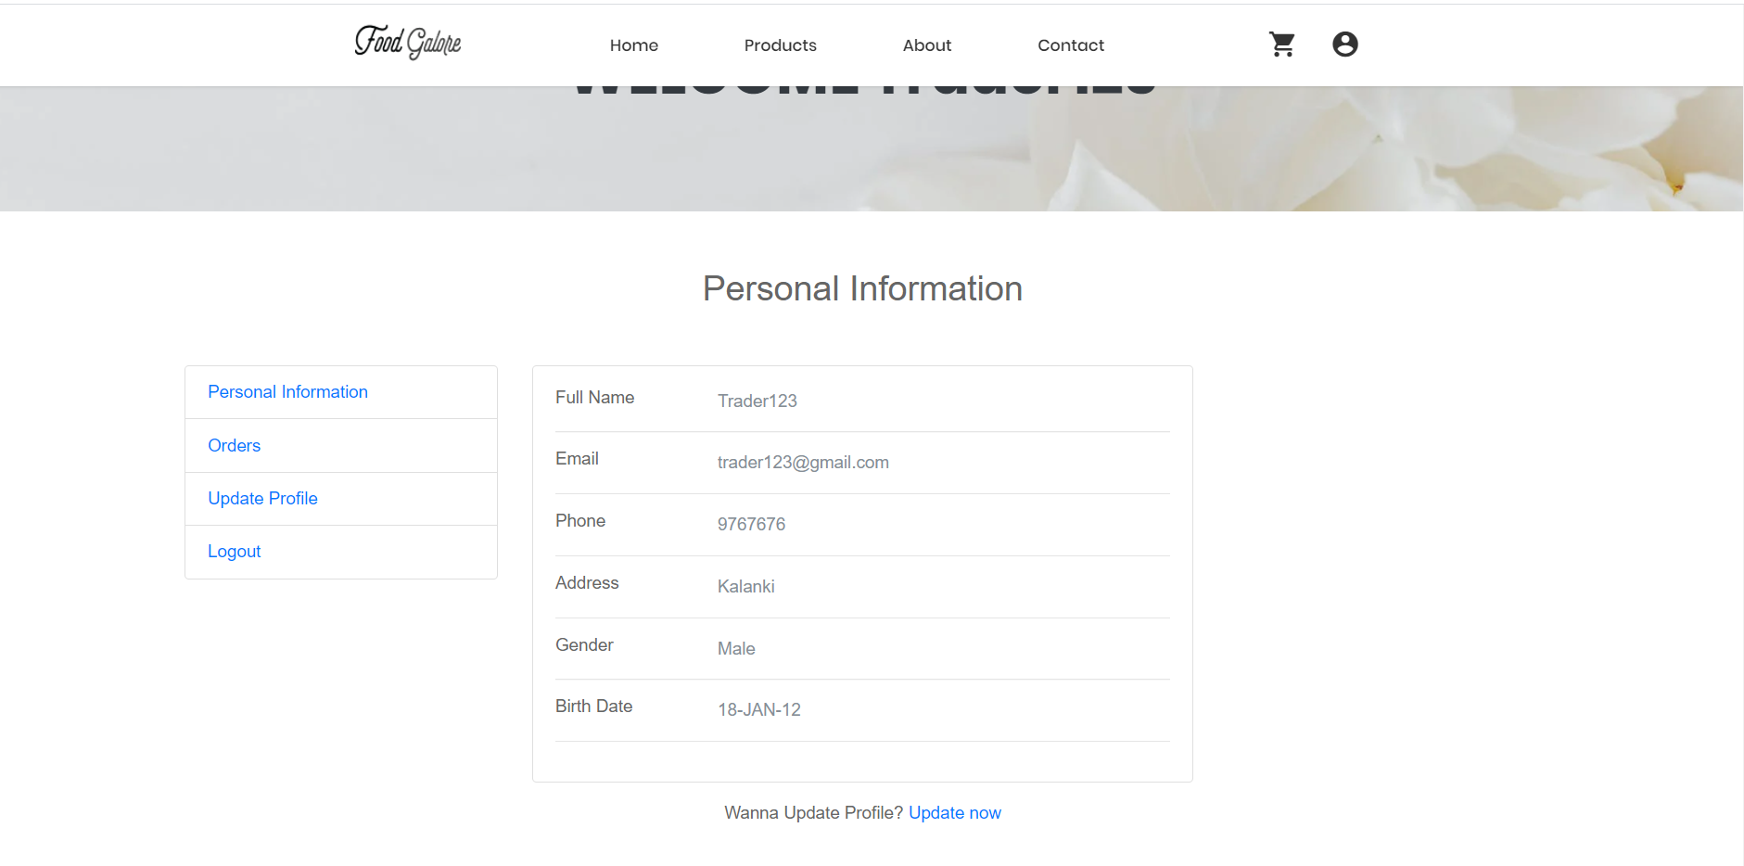

Action:Edit the personal information.

Steps: Once the correct trader login credentials are filled, you will see a page with a dashboard . You can also update your Shop Details, Personal Details as well as Contact Details.

Expected Results:You can change your personal information

Pass/Fail:Pass

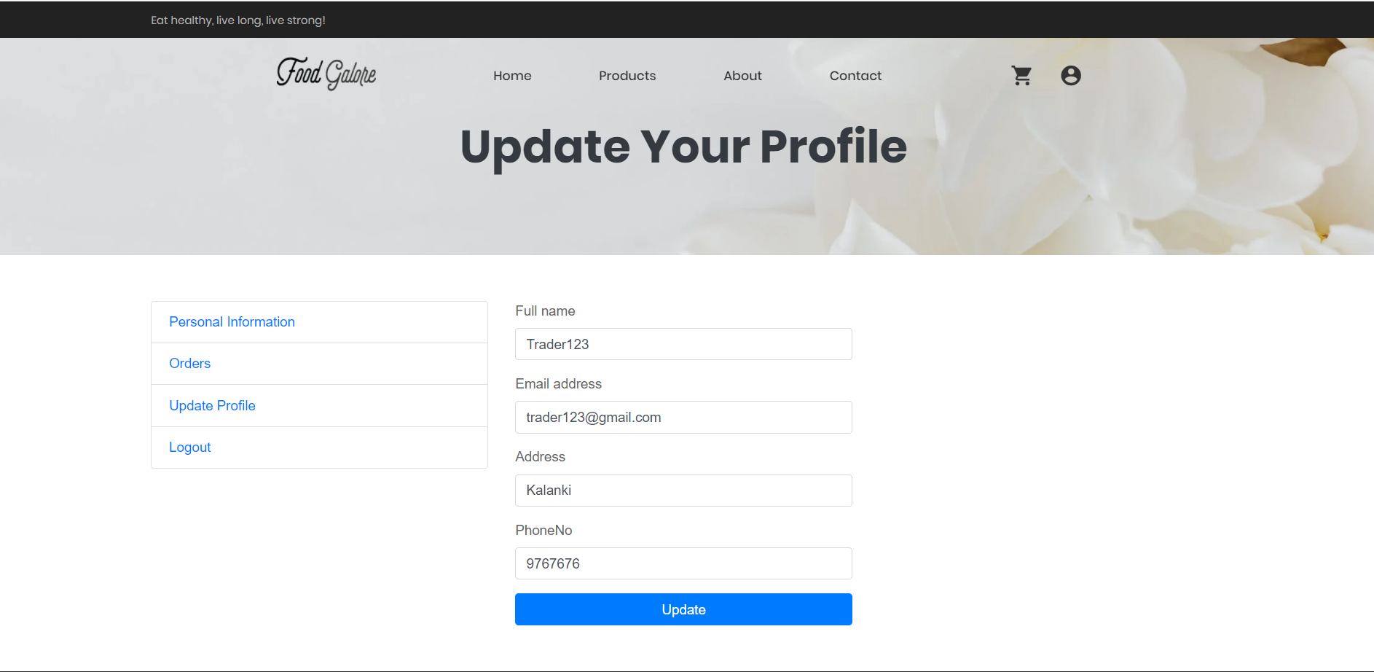

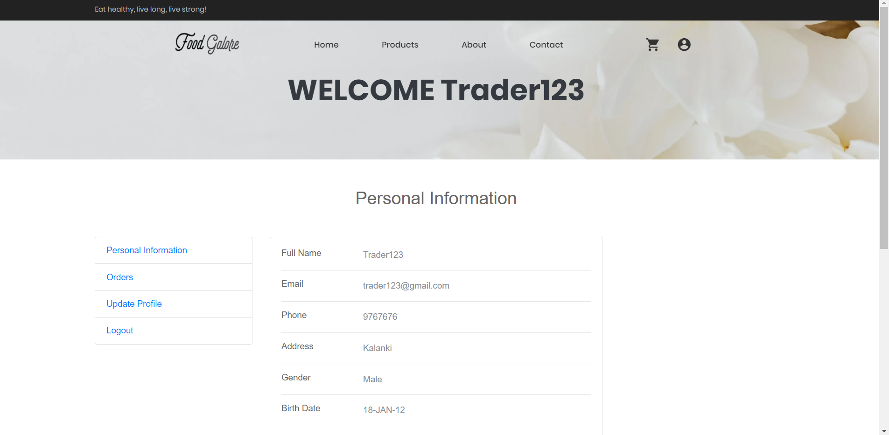

3. Shop

Action: Add shop.

Steps: Click on Shop button.

Expected Results: Traders can add a shop.

Pass/Fail: Pass

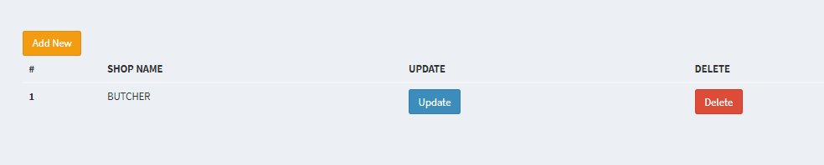

Action: Edit shop.

Steps: Enter the shop name and image link of the shop. Traders are only allowed to add two shops.

Expected Results: Redirect to edit shop page.

Pass/Fail: Pass

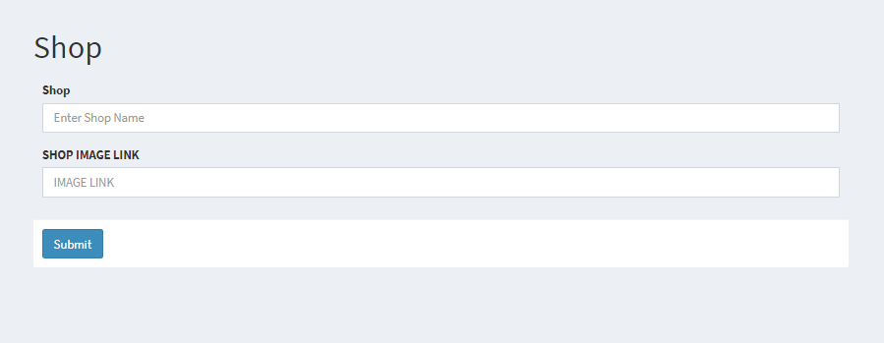

Action: Delete shop.

Steps: Click on Delete shop button

Expected Results: Delete the shop

Pass/Fail: Pass

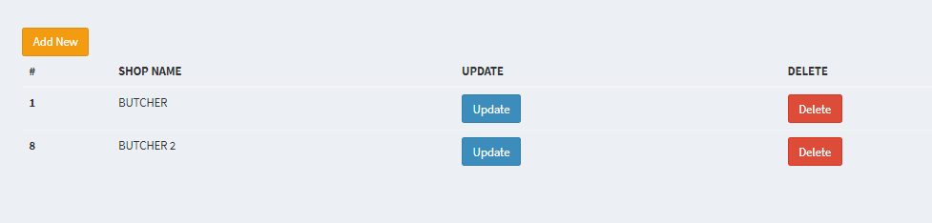

1. Products

Action: Add products page

Steps: Click on Products

Expected Results: added product page is displayed.

Pass/Fail: Pass

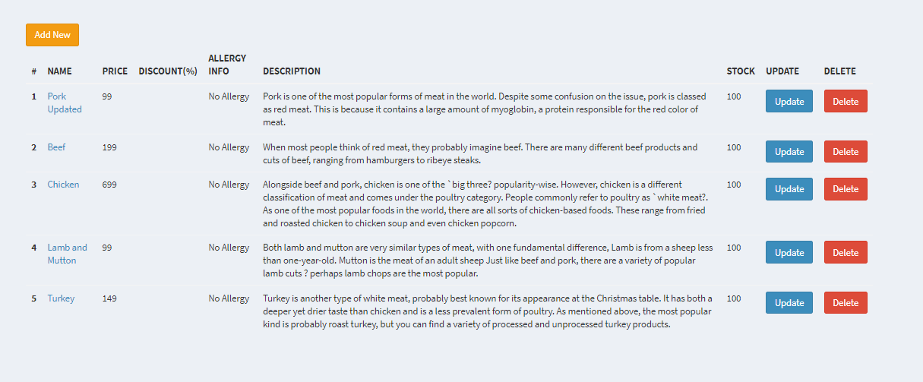

Action:Edit products details

Steps: Enter the product details.

Expected Results:Redirect to product page

Pass/Fail:Pass

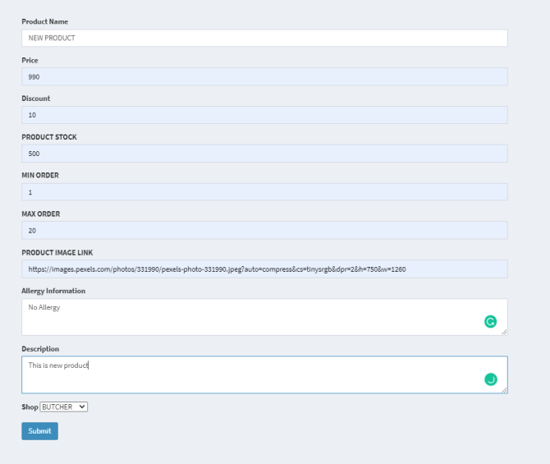

Action:Delete products details

Steps: Click on delete product details button.

Expected Results:Delete the shop

Pass/Fail: Pass



1. Logout

Action :Logout page..

Steps:

Expected Results: Traders can logout of the site.

Pass/Fail: Pass

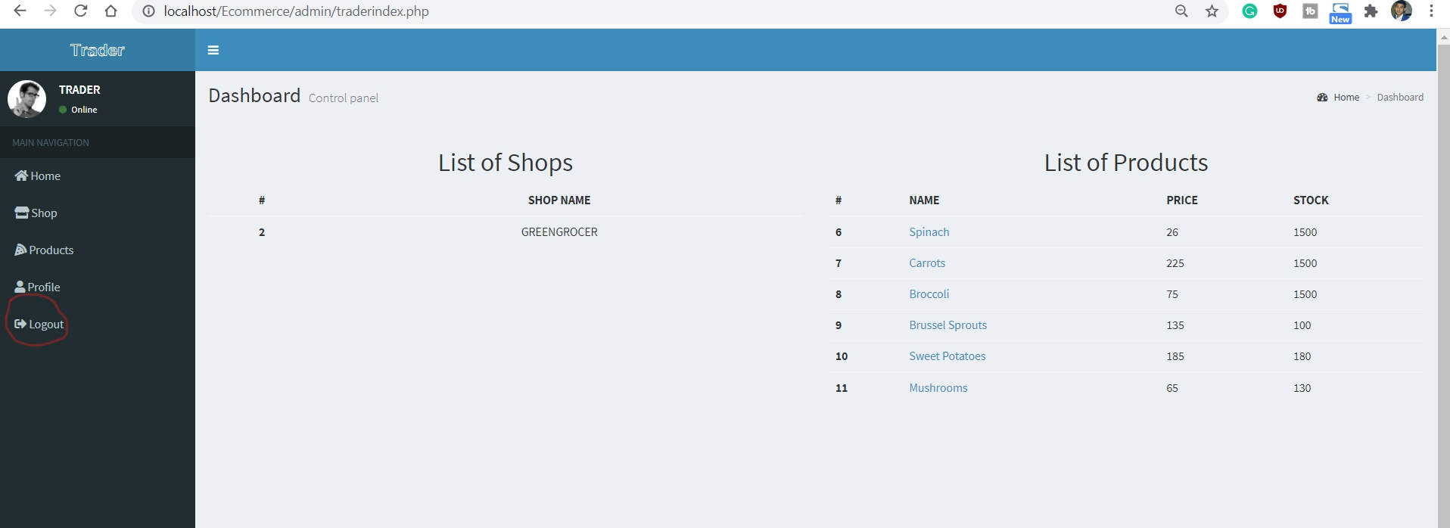

**Trader Interface Oracle Testing**

1. Sign In

Action: Sign in Page

Steps: Go to apex oracle.

Expected Results:Traders are directed to login page

Pass/Fail:Pass

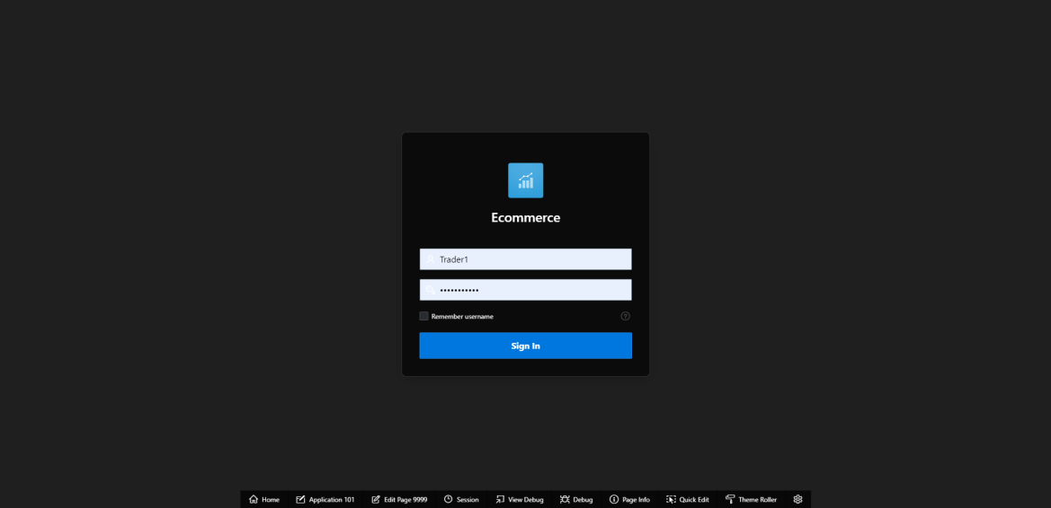

Action:correct password and email

Steps: Fill the correct information in an appropriate box.

Expected Results:Goes into the dashboard

Pass/Fail:Pass

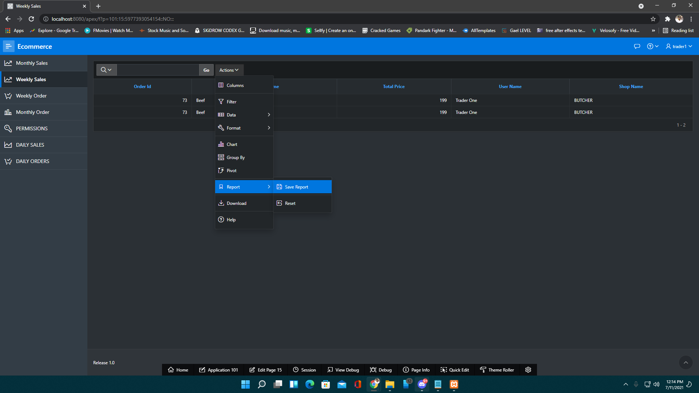

Action: incorrect password and email

Steps: Fill the incorrect login credentials.

Expected Results:An error message is displayed

Pass/Fail:Pass

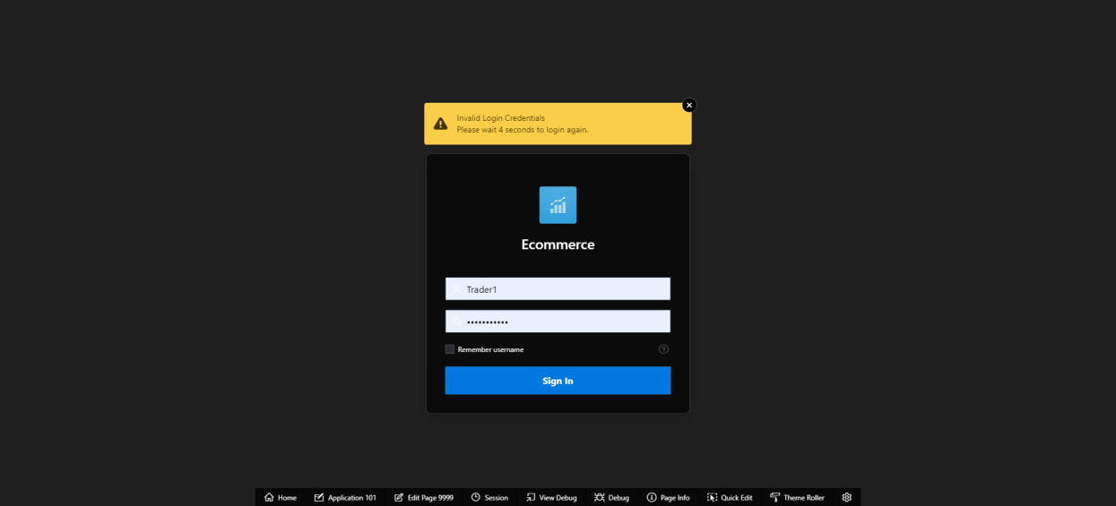

1. Reports

Action: View monthly sales

Steps: Click on Monthly sales.It shows the details of the products that are sold within a month.

Expected Results :Display the Trader's monthly sales

Pass/Fail: Pass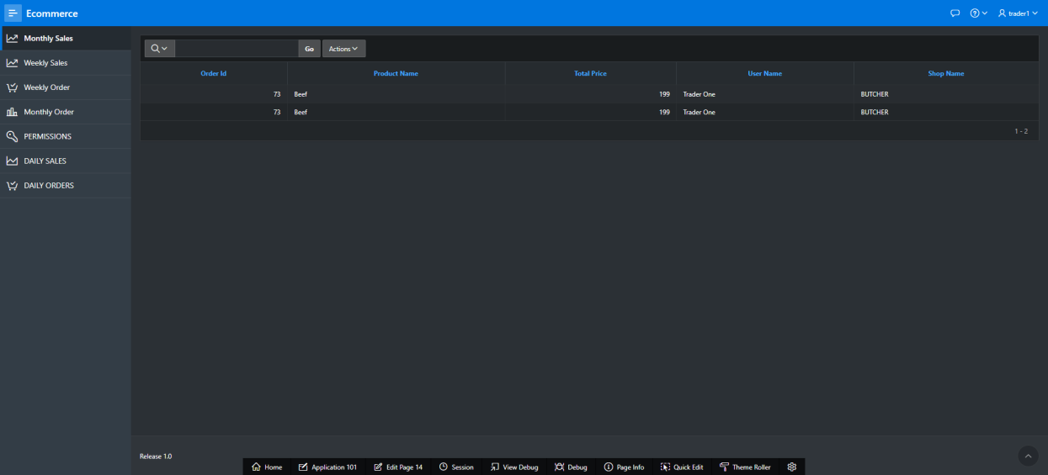

Action: View monthly order

Steps:Click on Monthly order.It shows the details of the products that are order within a month

Expected Results:display the Trader's monthly order

Pass/Fail:Pass

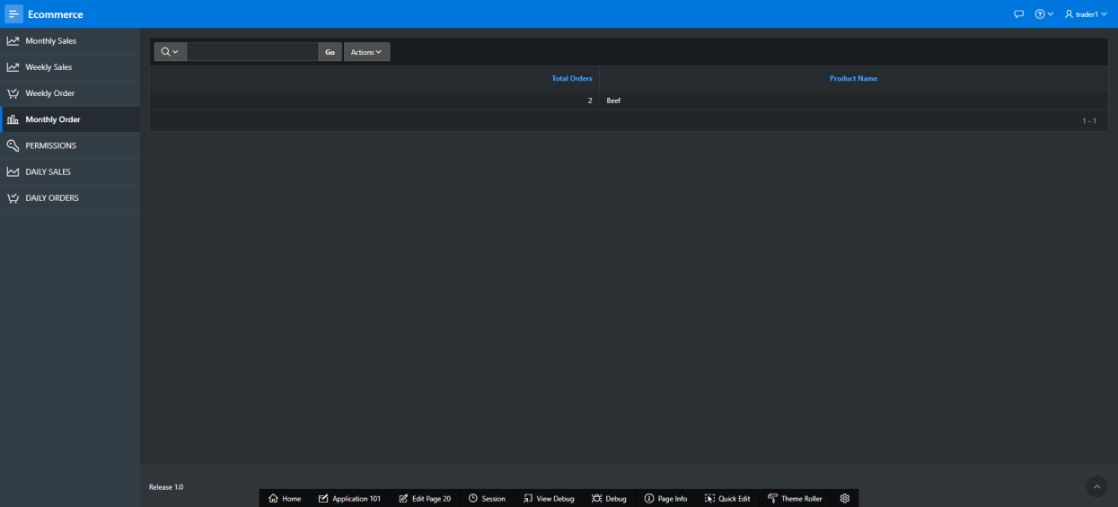

Action:view weekly sales

Steps:Click on weekly sales.It shows the details of the products that are sold within a week

Expected Results:display the Trader's weekly sales

Pass/Fail: Pass

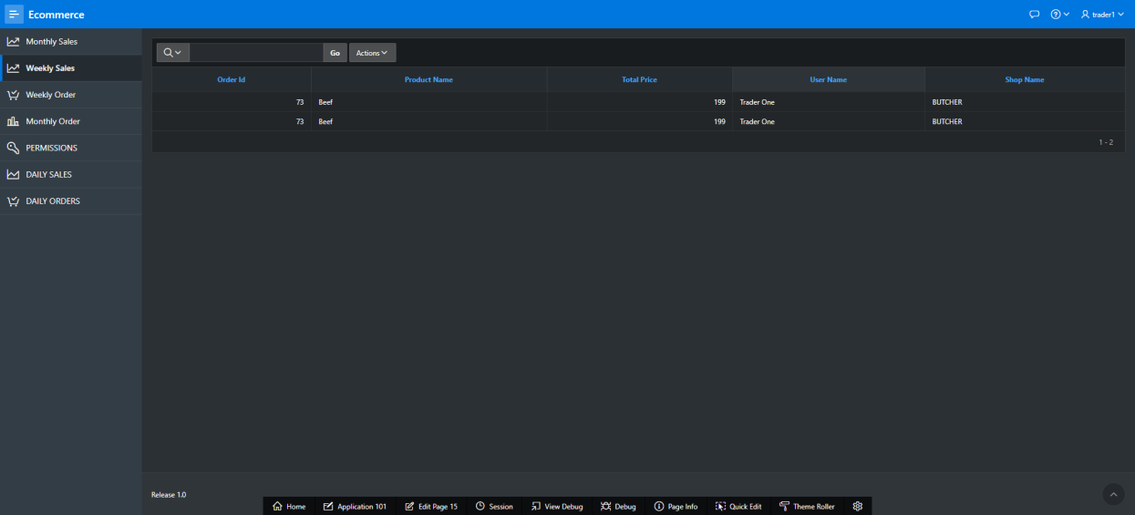

Action:view weekly order

Steps:Click on Weekly order..It shows the details of the products that are order within a week.

Expected Results:display the Trader's weekly order

Pass/Fail: Pass

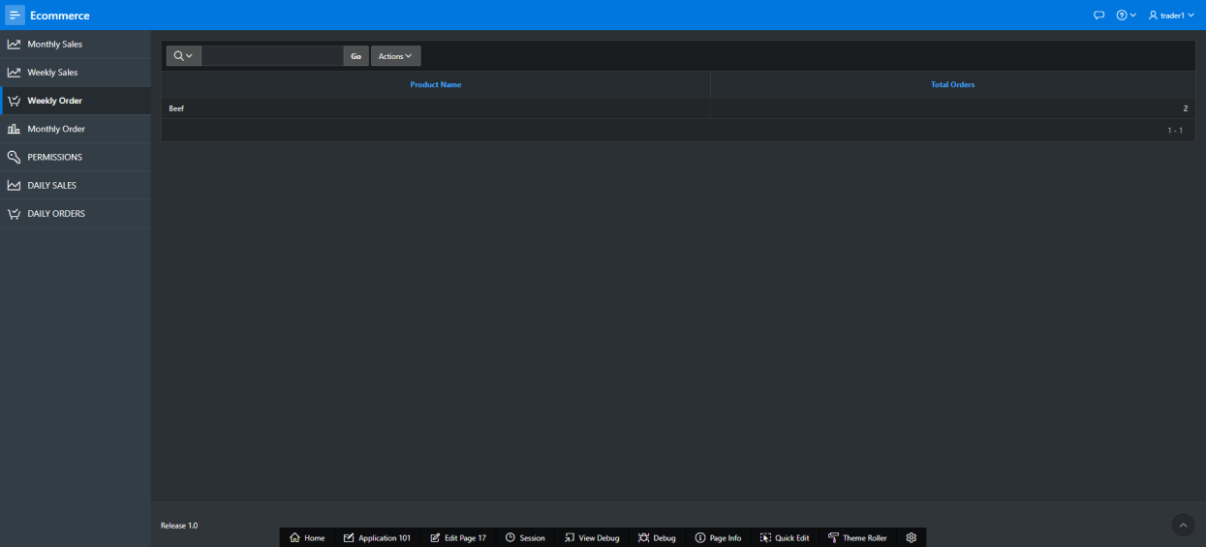

Action: View daily sales

Steps:Click on product of which you want to see or view rating and review.

Expected Results:display the Trader's daily sales

Pass/Fail:Pass

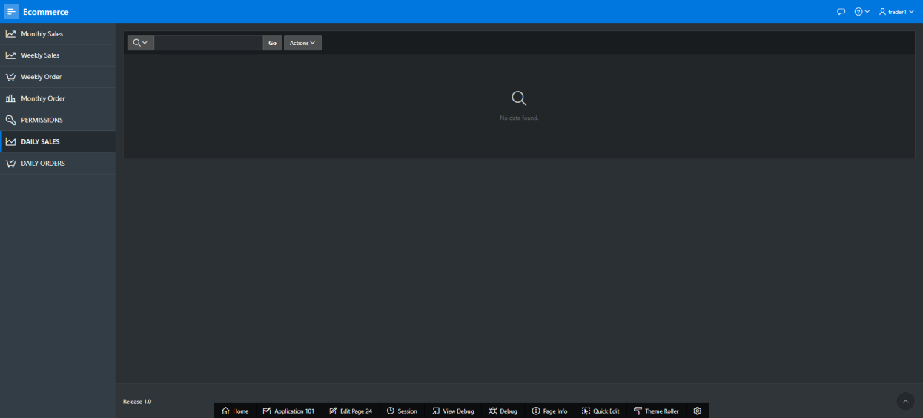

Action: View daily order

Steps:Click on daily order.It shows the details of the products that are order within 24 hours.

Expected Results: Display the Trader's daily order

Pass/Fail: Pass

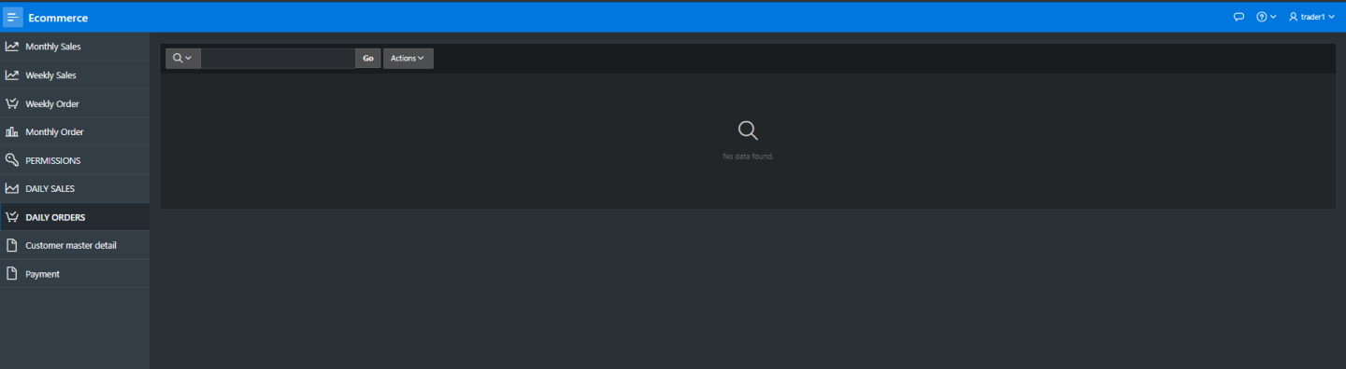

1. Logout

Action: Sign out page

Steps: Click on logout button.

Expected Results:You can log out from the dashboard.

Pass/Fail:Pass

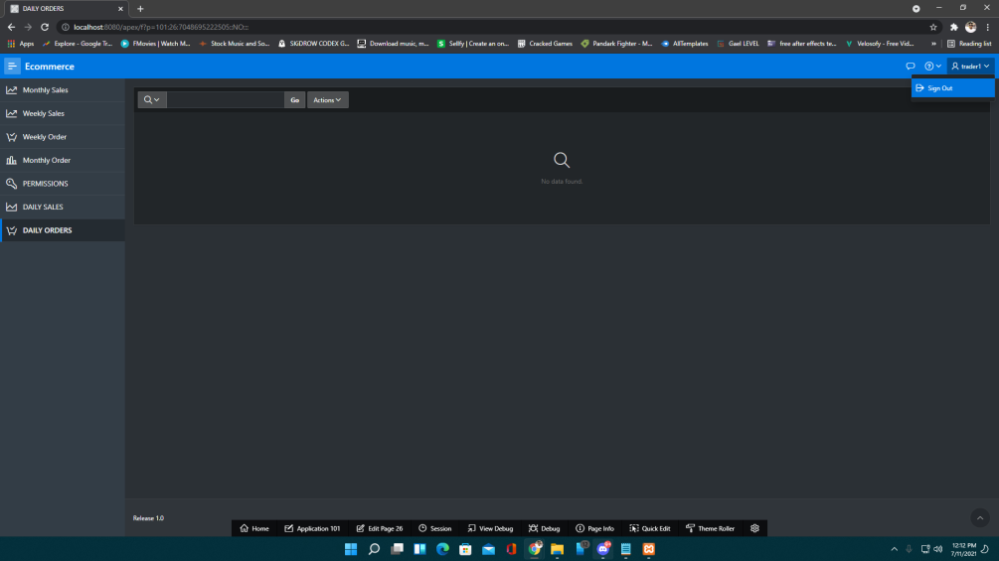

**Admin Interface Testing**

**Admin PHP**

1.Login

Action: Login with incorrect username and password.

Steps:

Expected Results: “Incorrect Email or Password” message pops up.

|  |
| --- |
|  |

Pass/Fail: Pass

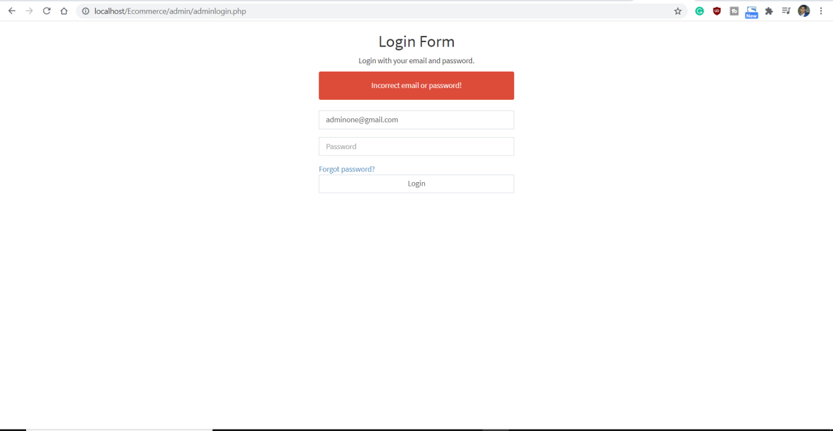

Action: Login with correct username and password.

Steps:

Expected Results: You get into the dashboard page.

Pass/Fail: Pass

|  |
| --- |
|  |

Action: When clicking on shops

Steps:

Expected Results: You can see the shop list

Pass/Fail: Pass

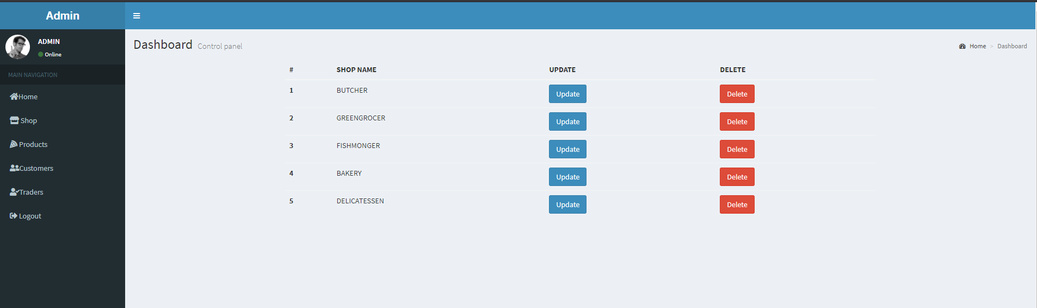

Action: When clicking on products

Steps:

Expected Results: You can see the products

Pass/Fail: Pass

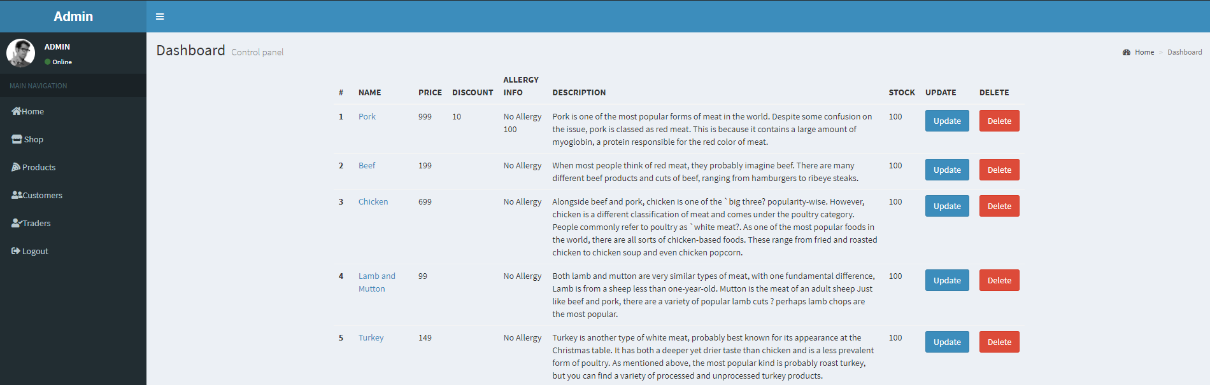

Action: When clicking on Update Products

Steps: Click on Update

Expected Results: You can Update and edit Products

Pass/Fail: Pass

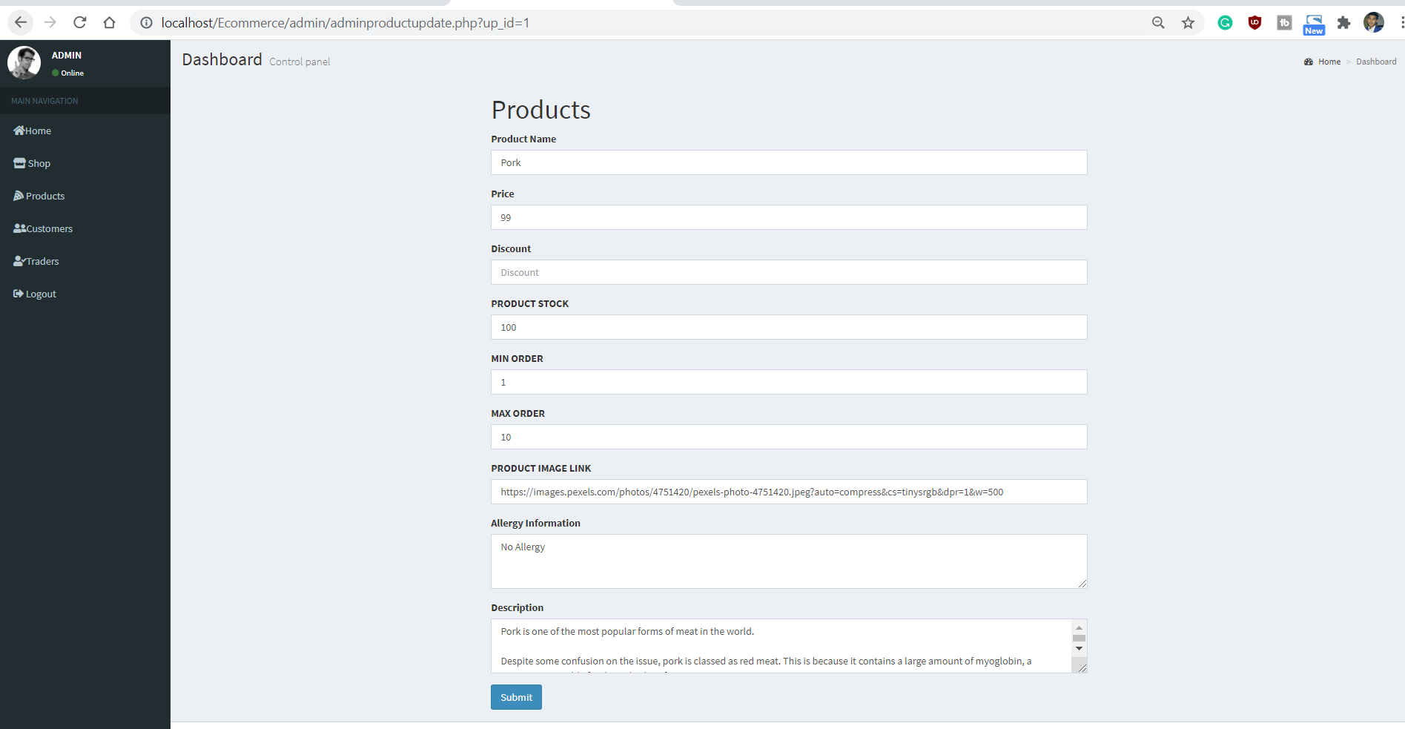

Action: When Clicking on Delete Products

Steps: Click on Delete

Expected Results: A product is deleted

Pass/Fail: Pass



Action: When clicking on Customers

Steps: Click on Customer

Expected Results: It will display details of Customers

Pass/Fail: Pass

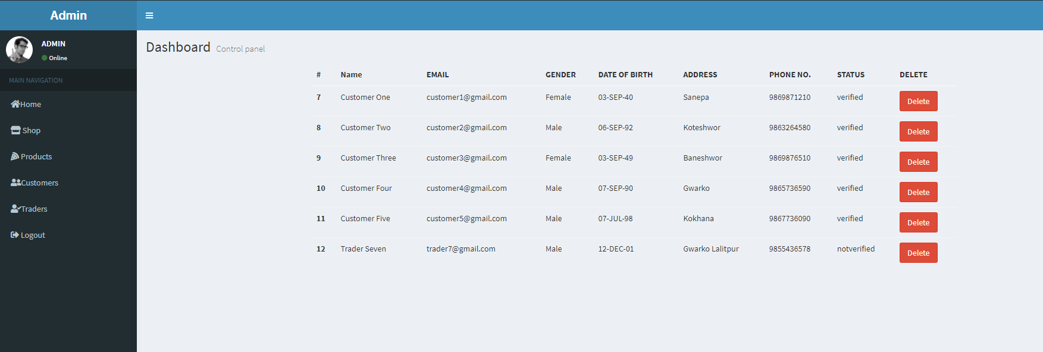

Action: When clicked on Delete

Steps: Click on Delete

Expected Results: Customer is deleted

Pass/Fail: Pass

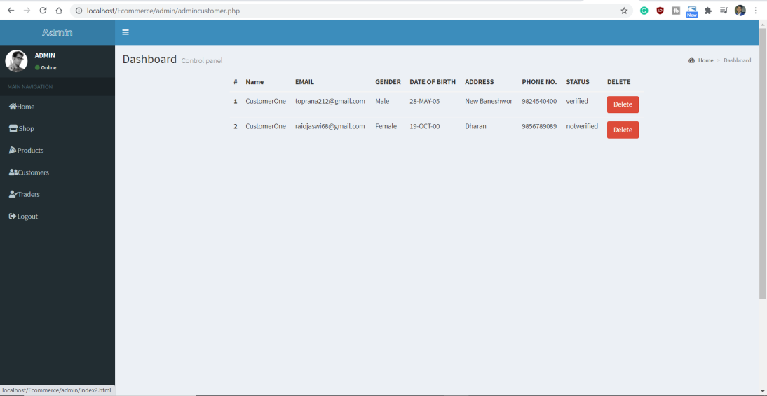

Action: When clicked on Traders

Steps: Click on Traders

Expected Results: Traders list will be displayed

Pass/Fail: Pass

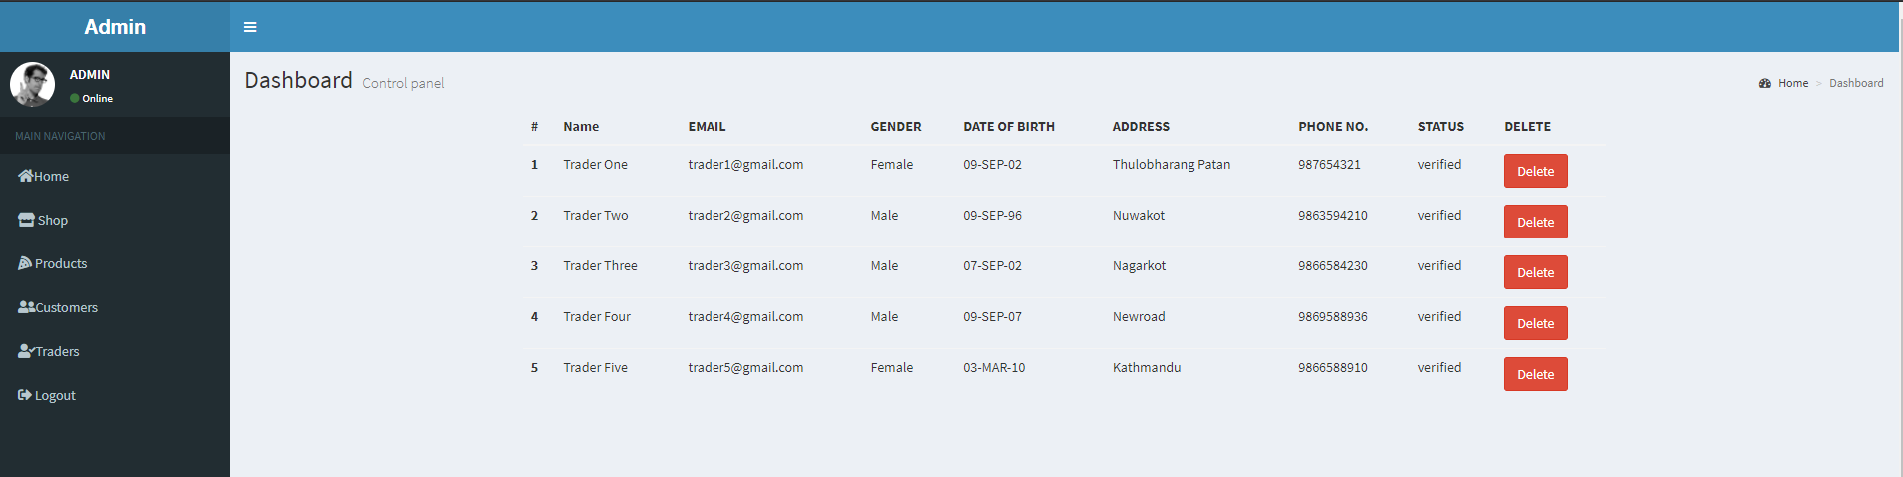

Action: When clicked on Delete

Steps: Click on Delete

Expected Results: Trader’s data will be deleted

Pass/Fail: Pass



Action: When clicked on logout

Steps: Click on Logout

Expected Results: You can logout from the page.

Pass/Fail: Pass

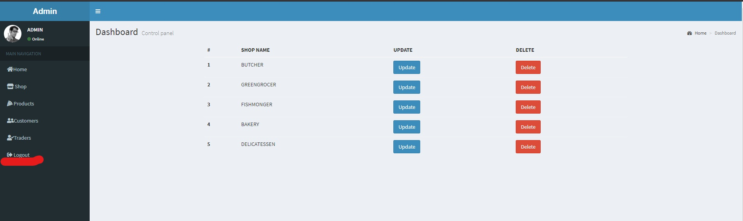

**Admin Oracle Testing**

**1. Sign In**

Action: Sign in page

Steps: Go to apex oracle.

Expected Results:Admins are directed to login page

Pass/Fail:Pass

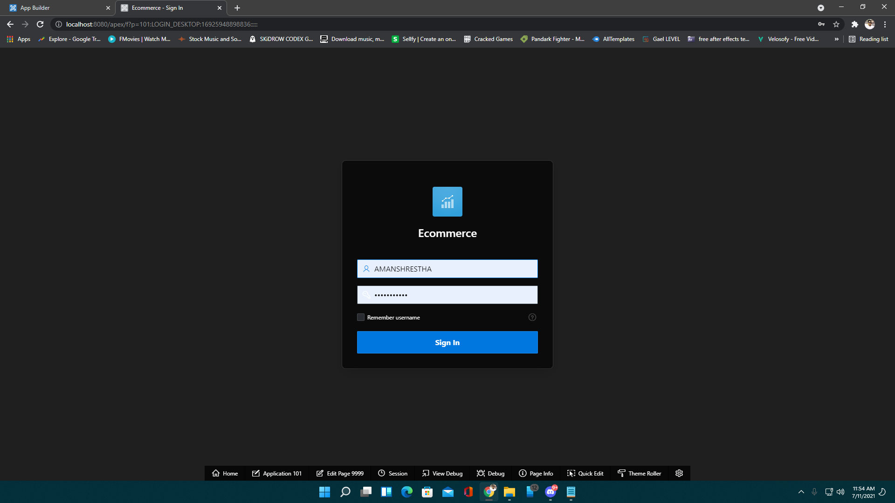

Action: Correct password and email

Steps: Fill the correct information in an appropriate box.

Expected Results:Goes into the dashboard

Pass/Fail:Pass

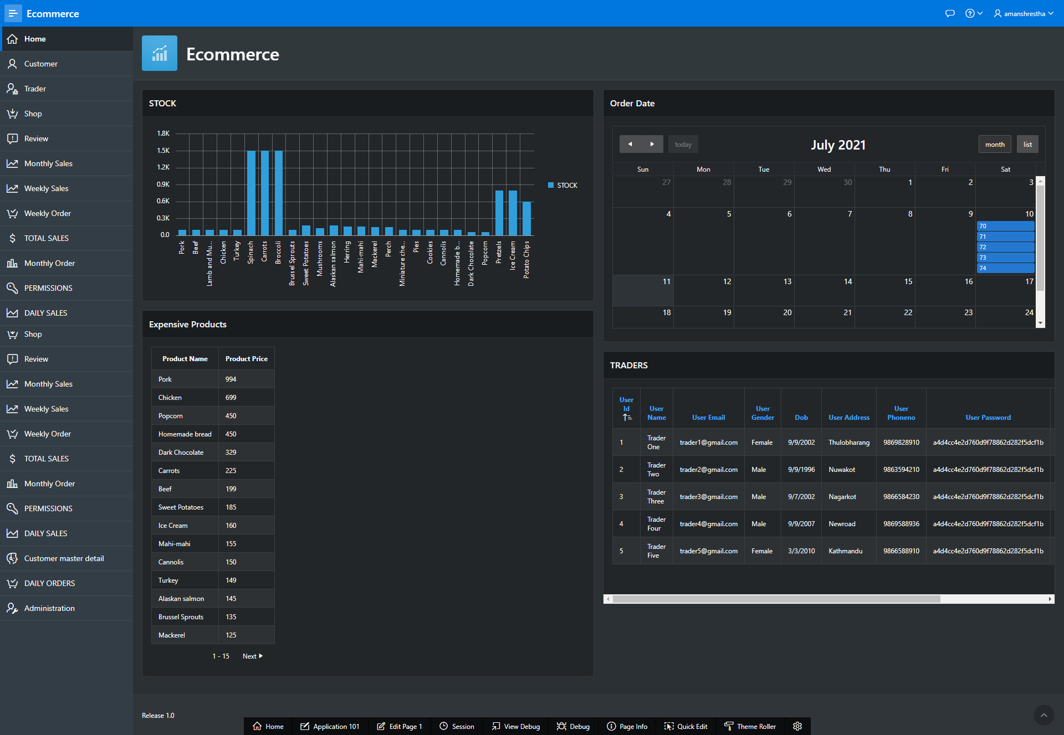

Action: If inserted incorrect password and Email

Steps:Fill the incorrect login credentials.

Expected Results: Error message is displayed

Pass/Fail:Pass

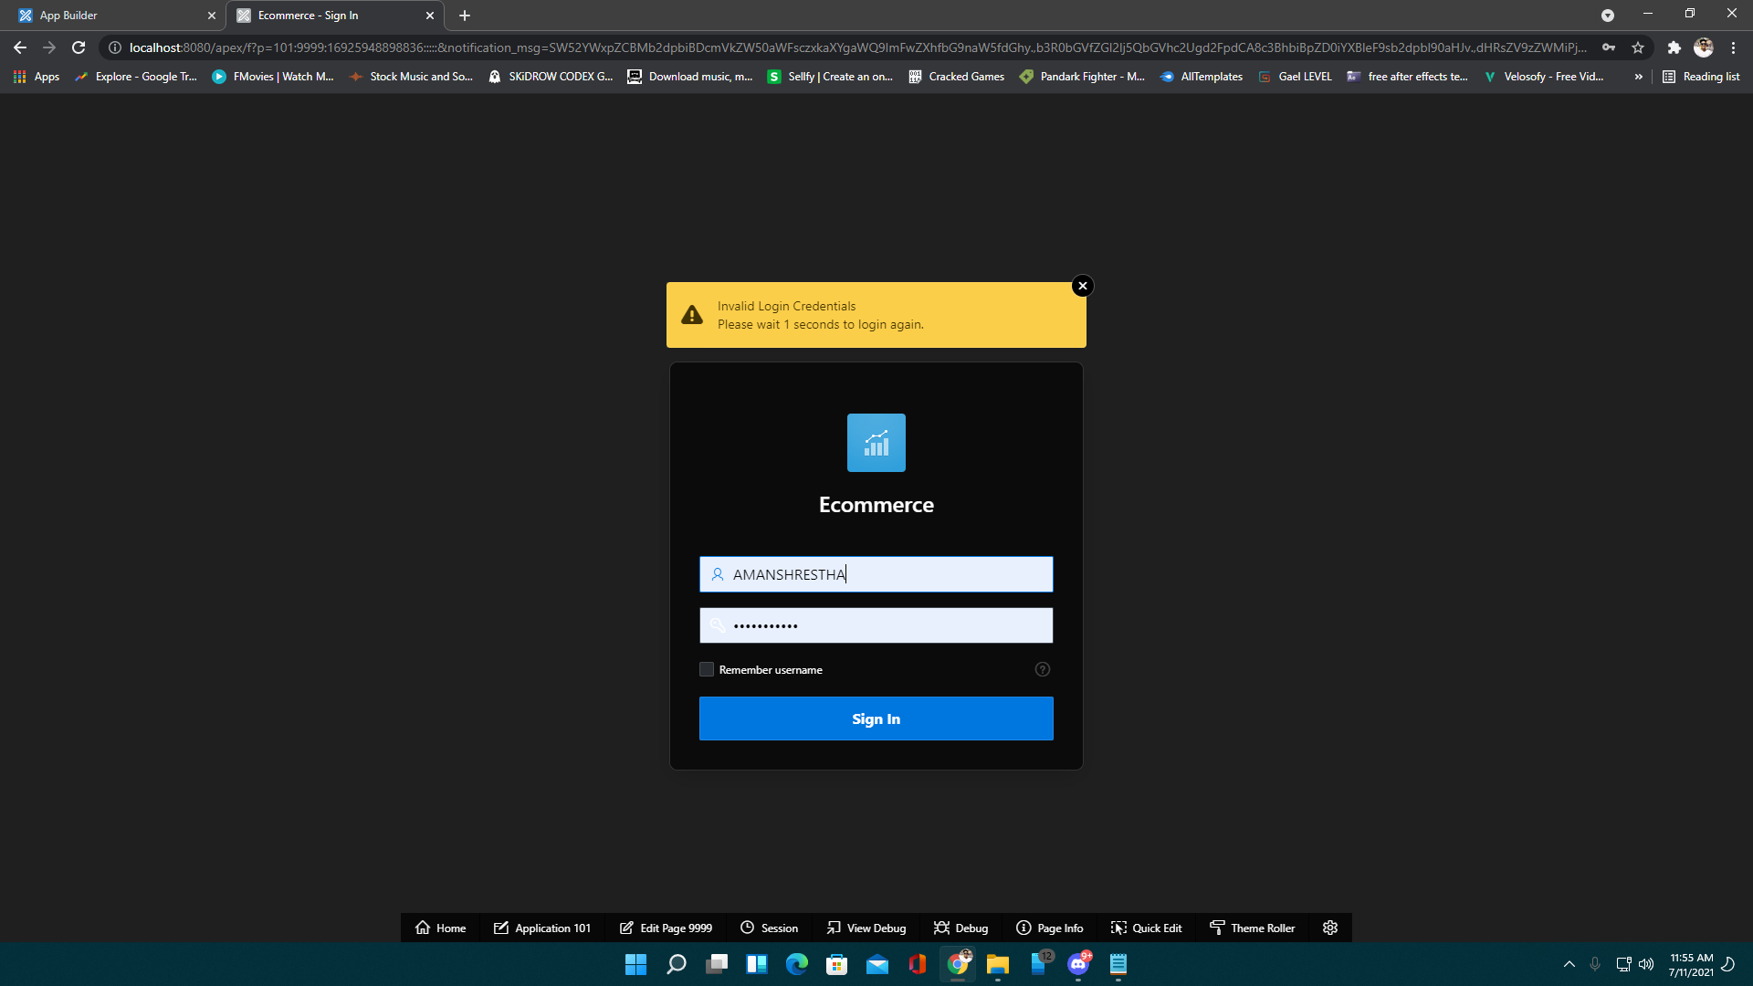

2. Dashboard

Action: View Customer

Steps: Click on Customer

Expected Results: You can view Customer’s data

Pass/Fail: Pass

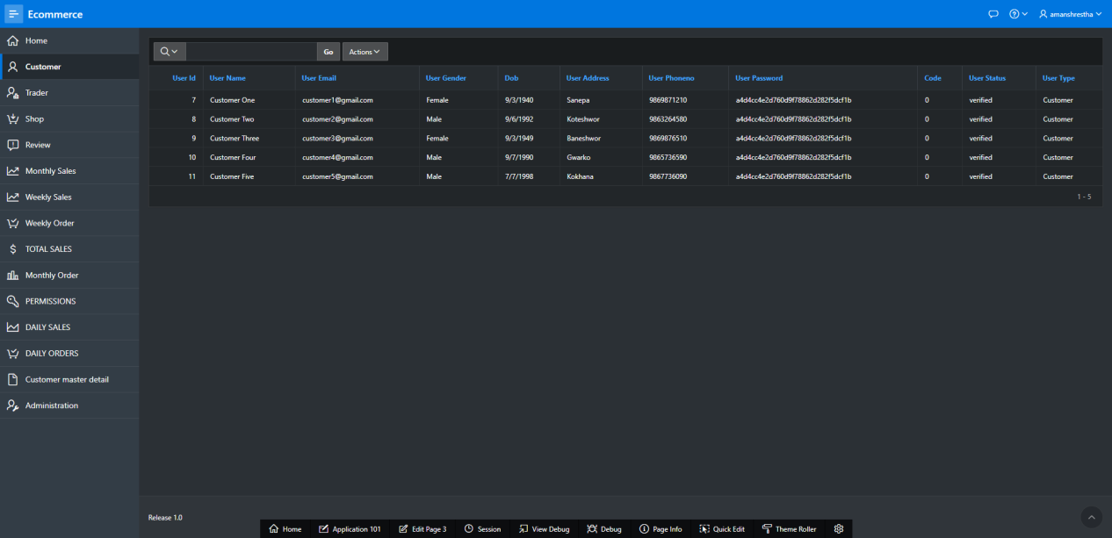

Action: View Trader

Steps: Click on Trader

Expected Results: Shows trader List.

Pass/Fail: Pass

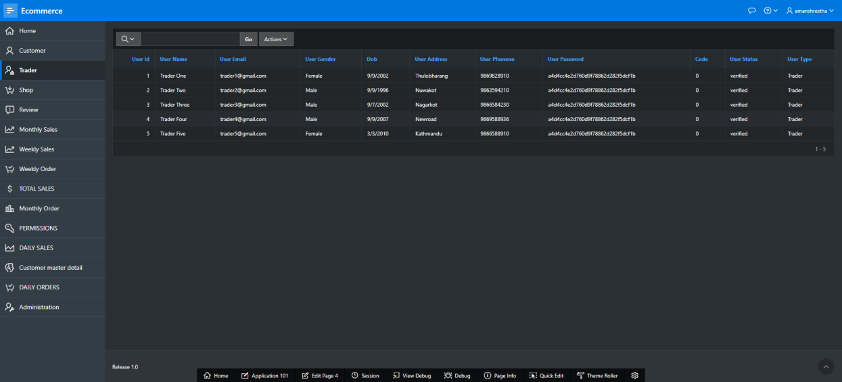

Action: View Shop

Steps: Click on Shop

Expected Results: Shows shop list.

Pass/Fail: Pass

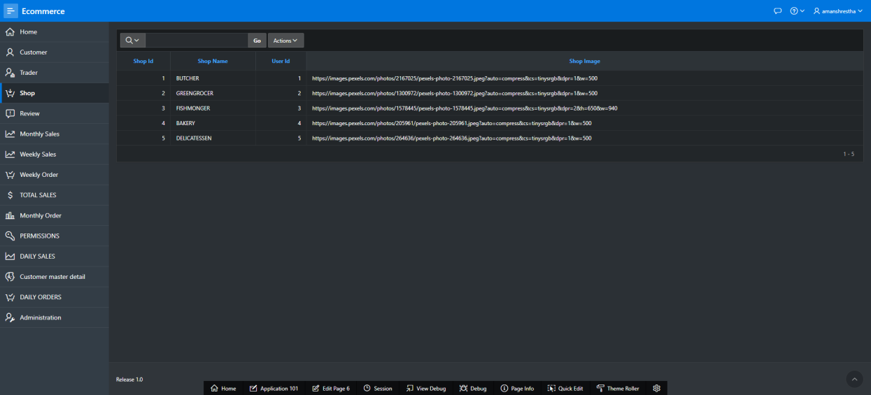

Action: View Review

Steps: Click Review

Expected Results: Shows Customer reviews

Pass/Fail:Pass

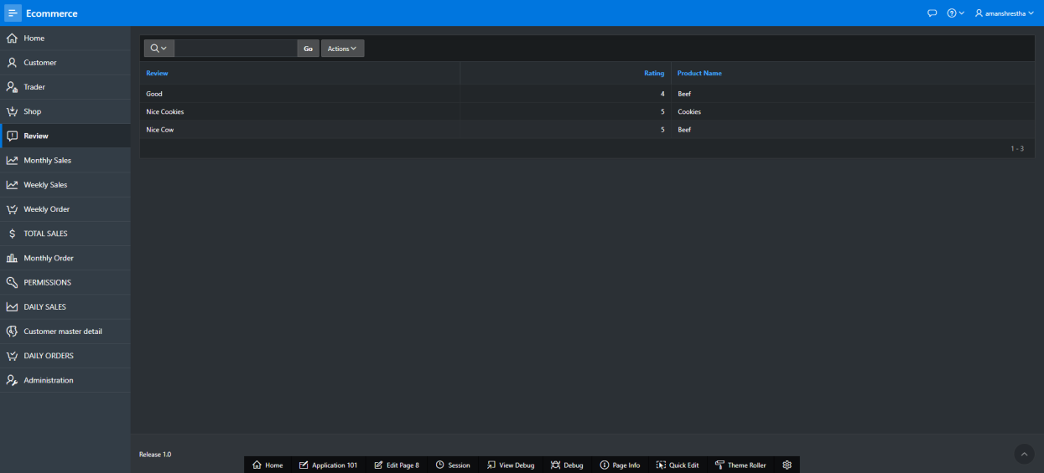

Action: View weekly sales

Steps: Click on Weekly Sales

Expected Results: Shows weekly sales of individual traders.

Pass/Fail:Pass

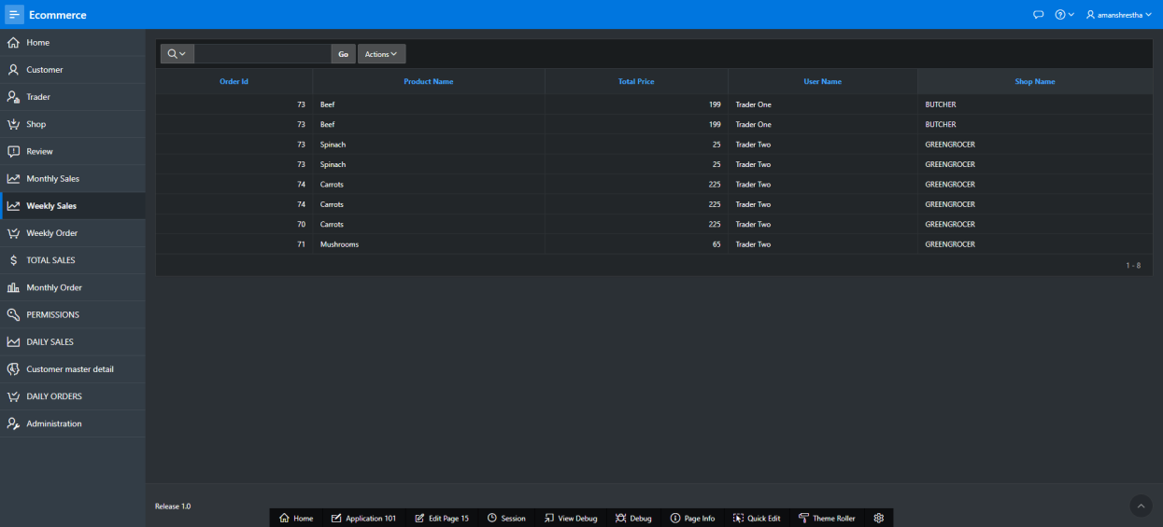

Action: View weekly order

Steps: Click on weekly order

Expected Results: Shows weekly order of individual traders.

Pass/Fail:Pass

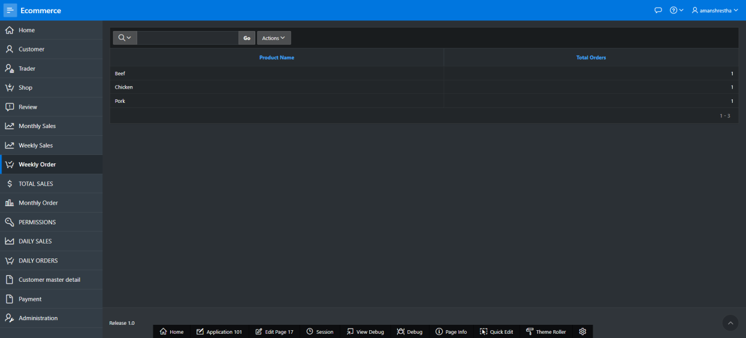

Action: View Total Sales

Steps:Click on total sales

Expected Results: Shows total sales of individual traders.

Pass/Fail: Pass

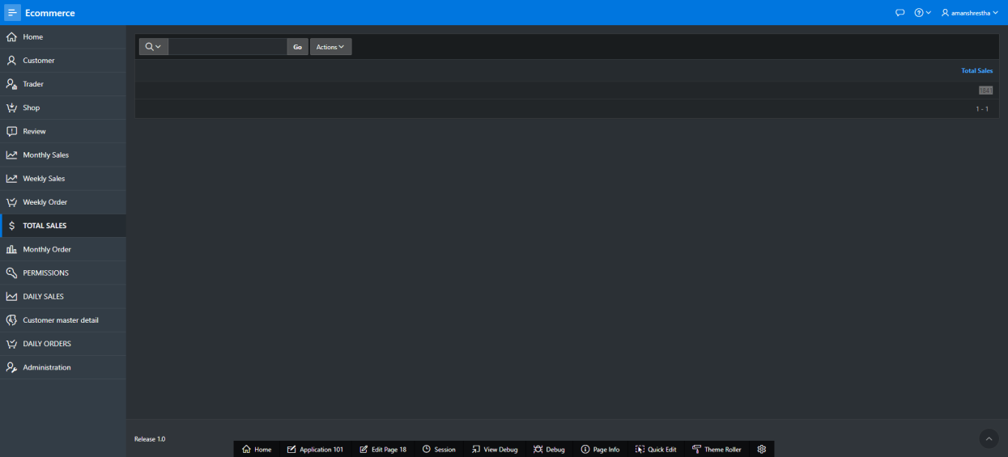

Action: View Monthly order

Steps: Click on monthly order

Expected Results:Shows monthly order of individual traders.

Pass/Fail: Pass

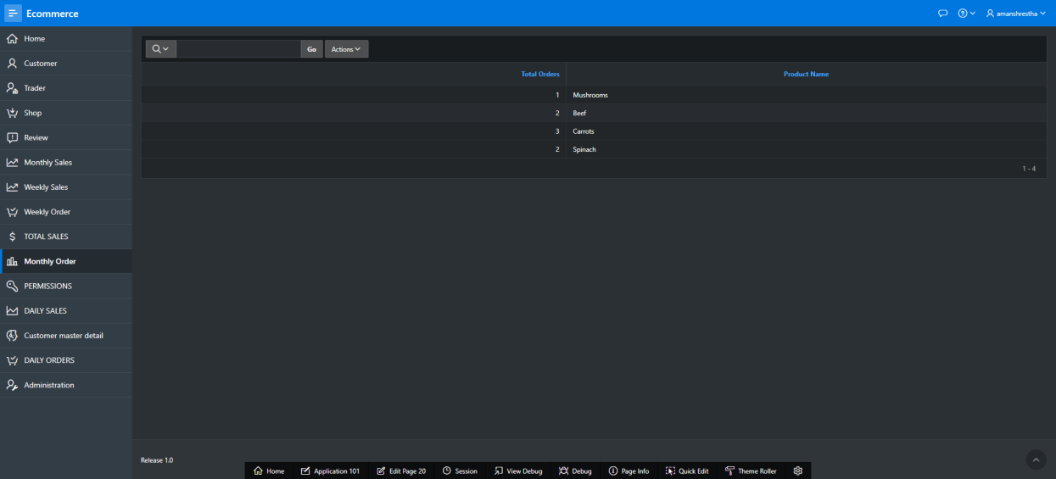

Action: View Daily Sales

Steps: Click on daily sales

Expected Results: Shows daily sales of individual traders.

Pass/Fail:Pass

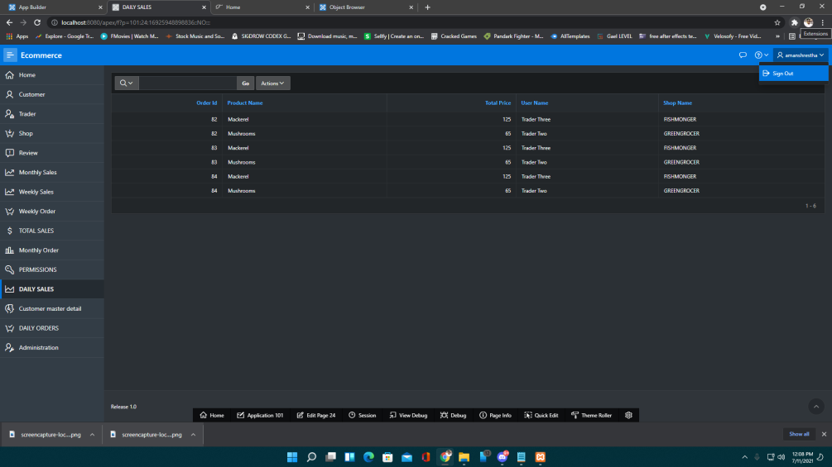

Action:View Daily Orders

Steps: Click on daily orders

Expected Results: Shows daily orders of individual traders.

Pass/Fail:Pass

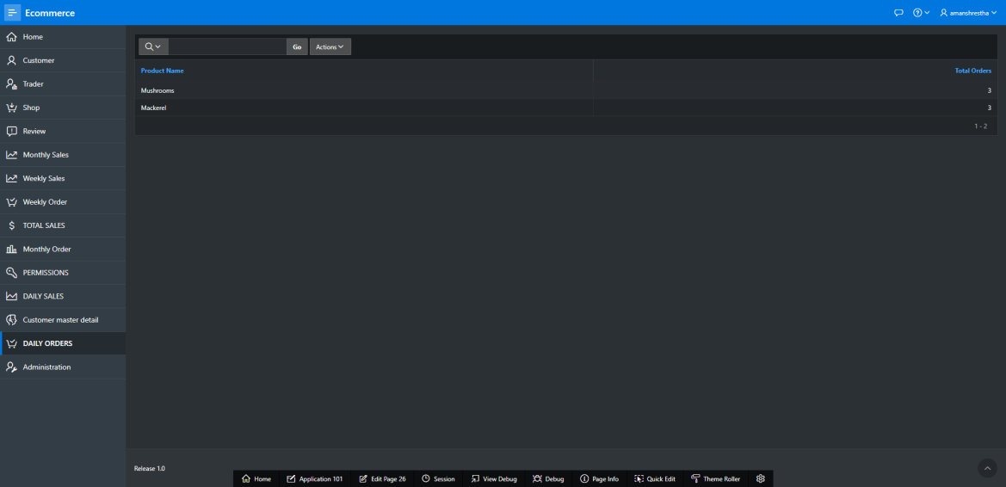

Action:View Customer master detail

Steps:Click on customer master detail

Expected Results: Shows customer master detail

Pass/Fail:Pass

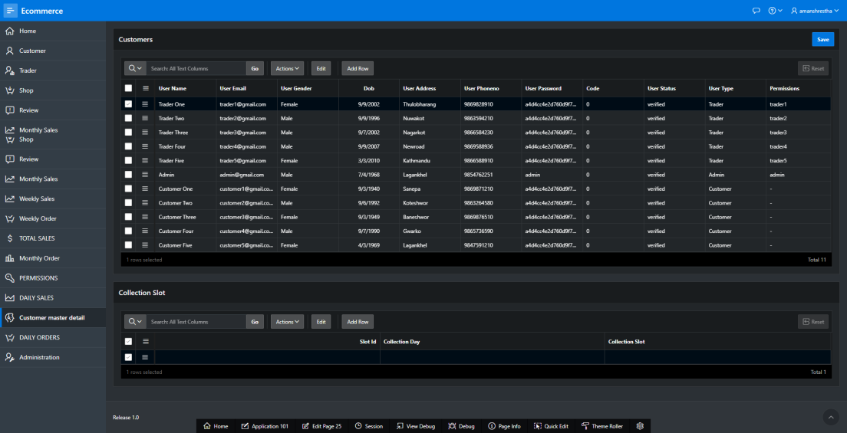

Action:Administration

Steps: Click on administration

Expected Results: Shows administration details

Pass/Fail:Pass

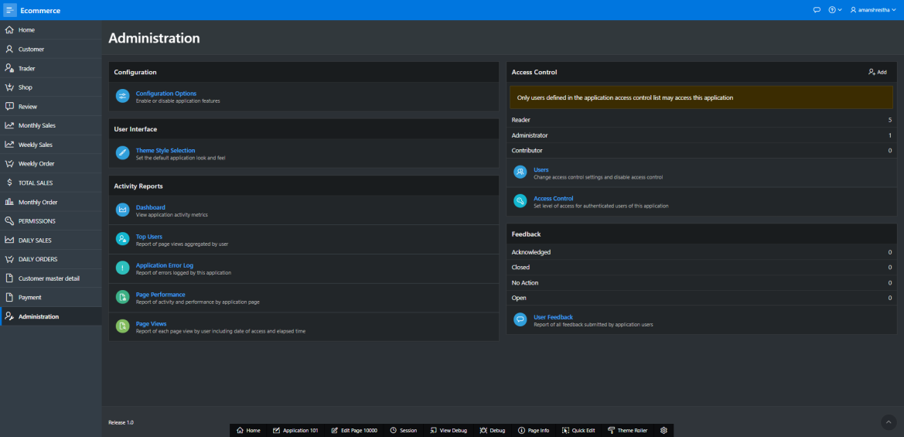

Action: Sign Out

Steps: Click on the logout button.

Expected Results: You can log out from the dashboard.

Pass/Fail: Fail



**FAQS**

